# 

# 

# FPT UNIVERSITY

# 

# 

# Vinhomes Grand Park On-demand Service

# Software Requirement Specification

# 

# Project Code: VinGiG

# Document Code: SRS – v1.1

# Group Members:

Nguyen Hoang Nam

Nguyen Ba Huy

Le Trung Duc

Le Nguyen Tien Nhat

# 

# Ho Chi Minh City, June 26th, 2023

# 

# 

# 

# TABLE OF CONTENT

**1. Introduction** **4**

1.1 Purpose 4

1.2 Scope 4

1.3 Definitions, Acronyms, and Abbreviations 6

1.4 References 6

1.5 Overview 7

**2. Overall Description** **8**

**3. Functional Requirements** **17**

3.1. Use Case Diagram 17

3.2. List of Use Cases 17

3.2.1. <Guest> Overview Use Case 17

3.2.1.1. <Guest> Login 18

3.2.1.2 <Guest> Register 21

3.2.1.3 <Guest> View service providers 24

Figure: <Guest> View service providers 24

3.2.2. <Customer> Overview Use Case 26

3.2.2.1. <Customer> View service providers 27

3.2.2.2. <Customer> Place Booking 30

3.2.2.3. <Customer> View booking history 34

3.2.2.4. <Customer> View current activities 38

3.2.2.5. <Customer> Cancel booking 41

3.2.2.6. <Customer> Review booking 43

3.2.2.7. <Customer> Chat 45

3.2.2.8. <Customer> View chat history 49

3.2.2.9. <Customer> Logout 52

3.2.2.10. <Customer> Update account information 54

3.2.3. <Provider> Overview Use Case 57

3.2.3.1. <Provider> View current activities 58

3.2.3.2. <Provider> Get notified for booking placement 60

3.2.3.3. <Provider> Accept booking request 62

3.2.3.4. <Provider> Decline booking request 66

3.2.3.5. <Provider> Mark Complete a Booking (Update booking status) 70

3.2.3.6. <Provider> Cancel a Booking (Update booking status) 72

3.2.3.7. <Provider> Chat 75

3.2.3.8. <Provider> View chat history 78

3.2.3.9. <Provider> View Booking History 81

3.2.3.10. <Provider> Review Booking 83

3.2.3.11. <Provider> Add Provider Service 86

3.2.3.12. <Provider> Edit Provider Service 89

3.2.3.13. <Provider> Deactivate Service (Soft Delete) 92

3.2.3.14. <Provider> View Transactions 94

3.2.3.15. <Provider> Deposit money into wallet 96

3.2.3.16. <Provider> Get Notified When Balance is Low 99

3.2.3.17. <Provider> View Subscription Plan 101

3.2.3.18. <Provider> Register a Subscription Plan 103

3.2.3.19. <Provider> Get Notified When Subscription is Close to End 106

3.2.3.20. <Provider> Logout 108

3.2.3.21. <Provider> Update account information 110

3.2.4. <Admin> Overview Use Case 113

3.2.4.1. <Admin> Add services categories 113

3.2.4.2. <Admin> Deactivate services categories 116

3.2.4.3. <Admin> Edit services type categories 118

3.2.4.4. <Admin> Add services 120

3.2.4.5. <Admin> Deactivate services 124

3.2.4.6. <Admin> Edit services 125

3.2.4.7. <Admin> Add building 128

3.2.4.8. <Admin> Deactivate building 131

3.2.4.9. <Admin> Edit building 133

3.2.4.10. <Admin> Activate provider 136

3.2.4.11. <Admin> Deactivate provider 138

3.2.4.12. <Admin> Edit provider 140

3.2.4.13. <Admin> Activate customer 143

3.2.4.14. <Admin> Deactivate customer 145

3.2.4.15. <Admin> Edit customer 147

3.2.4.16. <Admin> Add a badge 150

3.2.4.17. <Admin> Edit a badge 153

3.2.4.18. <Admin> Deactivate a badge 156

3.2.4.19. <Admin> Add a plan 158

3.2.4.20. <Admin> Edit a plan 161

3.2.4.21. <Admin> Deactivate a plan 164

3.2.4.22. <Admin> View transactions 168

3.2.4.23. <Admin> View subscription fee 171

3.2.4.24. <Admin> View booking history 174

3.2.4.25. <Admin> View booking commission fee 176

3.2.4.26. <Admin> View deposit 179

**4. Non-Functional Requirements** **181**

4.1. Usability 181

4.2. Reliability 182

4.3. Performance 182

# 

# 

# **1. Introduction**

## **1.1 Purpose**

This Software Requirements Specification provides readers with a closer look at the behaviors and the functionalities of the application VinGiG, Vinhomes Grand Park’s on-demand task service platform. The SRS encompasses a high-level use-case diagram, actors, use case details and other non-functional requirements of the system. The business rules are distributed across the use-case details where relevant. Additional information includes the names of authors, publish date and the scope that the project is in.

## 1.2 Scope

### This SRS applies to the VinGiG application, a third-party website for Vinhomes Grand Park residents to book on-demand local services or register to become a service provider.

### The application offers services such as AC services (repair/maintenance/cleansing), chores, Home maintenance (repainting/door battery replacement, sink and toilet unclogging), home-based care (baby sitting/elderly catering), medical home treatment (wound care/drip medication), culinary services (market shopping/cooking), and laundry.

### Features and functionality:

* + Admin’s management:
    - FE-ADM-01: Functions to manage buildings
    - FE-ADM-02: Functions to manage badges
    - FE-ADM-03: Functions to manage service categories
    - FE-ADM-04: Functions to manage services in a category
    - FE-ADM-05: Functions to manage subscription plans
    - FE-ADM-06: Functions to manage Customers
    - FE-ADM-07: Functions to manage Providers and Wallets
    - FE-PRO-08: Functions to view statistics of booking fees, subscription fees, transaction
  + Customer’s features:
    - FE-CUS-01: Functions to view provider services in a service option
    - FE-CUS-02: Functions to view all services offered by a provider on the provider’s page
    - FE-CUS-03: Functions to place a booking
    - FE-CUS-04: Functions to chat with booked provider and view chat history
    - FE-CUS-05: Functions to view current booking activities
    - FE-CUS-06: Functions to view booking history
    - FE-CUS-07: Functions to feedback and rate bookings completed
  + Provider’s features:
    - FE-PRO-01: Functions to view all the services on his/her page
    - FE-PRO-02: Functions to mark the provider’s availability status
    - FE-PRO-03: Function to manage (add, edit, delete, hide) the services on his home page
    - FE-PRO-04: Functions to get notified for the booking placement
    - FE-PRO-05: Functions to accept/deny a booking
    - FE-PRO-06: Functions to mark complete/cancel the booking upon acceptance.
    - FE-PRO-07: Functions to chat with booked customer and view chat history
    - FE-PRO-08: Functions to view current booking activities
    - FE-PRO-09: Functions to view booking history
    - FE-PRO-10: Functions to view monthly statistics of booking fees, subscription fees, deposits
    - FE-PRO-11: Functions to manage wallet and view transactions
    - FE-PRO-12: Functions to register a subscription plan and get notified when the due date is close.
    - FE-CUS-13: Functions to feedback and rate customers upon booking completion.

## **1.3 Definitions, Acronyms, and Abbreviations**

### GiG: on-demand tasks that are needed occasionally and implies little loyalty.

* Customer: registered users, who place a booking for a particular service.
* Provider: a registered service provider who creates posts of services, responds to the booking placement of the customers and must adhere to the policies and the services available to the system.
* Provider Service: each service has many providers, each of which is unique and of the discretion of the provider.

## 1.4 References

## 1.5 Overview

This SRS document consists of two main sections: Overall Description and Specific Requirements. The Overall Description section provides a general understanding of the product, its functions, user characteristics, constraints, assumptions, dependencies, and requirement subsets. The Specific Requirements section contains detailed requirements for each user category (Customer, Provider, and Admin) along with their respective features and operations. The section also includes non-functional requirements related to the technology stack used for the development of the application.

# 2. Overall Description

### The VinGiG application is a third-party website that enables users to book various on-demand local services provided by Vinhomes Grand Park. The application serves as a platform for connecting users and service providers. The following factors affect the product and its requirements:

### Product Perspective:

### The VinGiG application is an independent system that interacts with users, service providers, and administrators.

### It integrates with the Vinhomes Grand Park service infrastructure to facilitate seamless service bookings and management.

### Product Functions:

### User Account and Authentication: Users can create accounts, log in, manage their account information, and change their passwords.

### Service Booking: Customers can browse available services, select a provider, chat with providers, and rate/review providers after receiving services.

### Booking History: Customers can view their booking history.

### Provider Profile: Providers can view and edit their information.

### Service Operation: Providers can select services to provide, chat with customers, confirm order placements, and confirm service completions.

### Service History: Providers can view their service history, including ratings, reviews, badges, and order quantity.

### Admin Management: Admins can manage services, customers, providers, and financial aspects of the application, including the ability to modify service details, register providers to services, view order histories, and adjust commission fees.

### User Characteristics:

### Customers: Individuals who require on-demand local services.

### Providers: Service professionals who offer their expertise and services through the platform.

### Administrators: Responsible for managing the application, overseeing customer/provider interactions, and maintaining the financial aspects of the system.

### Constraints:

### Front-end technology: React

### Back-end technology: Java frameworks (Spring Boot)

### Assumptions and Dependencies:

### The VinGiG application assumes an internet-connected environment for customers, providers, and administrators to access and interact with the platform.

### The application depends on the availability and functionality of the Vinhomes Grand Park service infrastructure for seamless service bookings and management.

### Requirements Subsets:

### The SRS defines requirements for customer management, service booking, provider management, and admin management, addressing the needs of each user category within the VinGiG application.

# **3. Functional Requirements**

### **3.1. Use Case Diagram**

### 

Figure: Use Case Diagram

### **3.2.** **List of Use Cases**

#### **3.2.1.** **<Guest> Overview Use Case**

#### 

Figure: <Guest> Overview use case

##### **3.2.1.1.** **<Guest> Login**

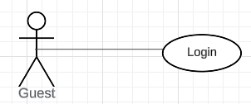

Figure: <Guest> Login

**Use Case Specification**

| **USE CASE – UC01** | | | |
| --- | --- | --- | --- |
| **Use Case No.** | **UC01** | Use Case Version | 1.1 |
| **Use Case Name** | Login | | |
| **Author** | Nguyen Ba Huy | | |
| **Date** | 07/06/2023 | **Priority** | Normal |
| **Actor:**  - Guest  **Summary:**  - This use case allows the user to login to the system.  **Goal:**  - Guest can login to the system  **Trigger:**  - Guest inputs username and password and clicks login  **Precondition:**  - Guest is on login screen  **Post Conditions:**  - Success: User logs into the system successfully  **Main Success Scenario:**     | Step | Actor Action | System Response | | --- | --- | --- | | 1 | Guest goes to the login screen | The system requires the following inputs from User include:  · Username: text, required  · Password: text, required  . Role: checkbox, required | | 2 | User inputs information. |  | | 3 | User clicks button “Login” | The system shows a message that the user has logged in successfully  [Exception 1] |     **Exception 1:**   | **Step** | **Cause** | **System Response** | | --- | --- | --- | | 1 | Invalid username or password | System shows the message “Username or password is not correct.” |     **Relationship:** N/A.  **Business rule:**   * User password character is secured and hidden with special character (*) | | | |

##### 

##### **3.2.1.2.** **<Guest> Register**

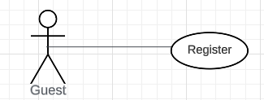

Figure: <Guest> Register

**Use Case Specification**

| **USE CASE - UC02** | | | |
| --- | --- | --- | --- |
| **Use Case No.** | UC02 | Use Case Version | 1.1 |
| **Use Case Name** | Register a new account | | |
| **Author** | Nguyen Ba Huy | | |
| **Date** | 07/06/2023 | **Priority** | Normal |
| **Actor**:  - Guest  **Summary**:  - This use case allows user to register an account  **Goal**:  - Guest can register an account  **Trigger**:  - The guest inputs information and clicks the “Register” button.  **Precondition**:  - Guest is viewing the register screen.  **Post Conditions:**  - Success: User registers a new account in the system successfully.  **Main Success Scenario:**   | **Step** | **Actor Action** | **System Response** | | --- | --- | --- | | 1 | Guest goes to the register screen | The system requires the following input from Guest includes:  · Username: text, required  · Password: text, required  · Confirm password: text, required  · Name: text, required  · Email: text, required  · Phone: text as number, required  . Role: checkbox, required | | 2 | Guest inputs information. |  | | 3 | Guest clicks “Register” | The system check validation and show message that the user has registered successfully  [Exception 1] |   Exception 1:   | **Step** | **Cause** | **System Response** | | --- | --- | --- | | 1 | Username is used by another account | System shows message “Username is unavailable” |   **Relationship**: N/A.  **Business rule:**  · Password and confirm password field must be hidden with special character and must be the same.  · The system validates user input with the following constraints:  o Username: unique and have more than 6 and fewer than 20 characters  o Phone number: number a format  o Email: email a format  o Password: Have fewer than 20 characters  o The confirm password matches the password  o Only one of three role checkboxes must be checked | | | |

##### **3.2.1.3.** **<Guest> View service providers**

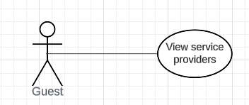

##### Figure: <Guest> View service providers

**Use Case Specification**

| **USE CASE - UC03** | | | |
| --- | --- | --- | --- |
| **Use Case No.** | **UC03** | **Use Case Version** | 1.1 |
| **Use Case Name** | View service providers | | |
| **Author** | Nguyen Ba Huy | | |
| **Date** | 07/06/2023 | **Priority** | Normal |
| **Actor:**  - Guest  **Summary:**  - This use case allows the user to view providers of a service in the system.  **Goal:**  - Guest can see the list of service providers.  **Trigger:**  - Guest clicks on one service from the service list in the homepage.  **Precondition:**  - Guest is on the home screen.  **Post Conditions:**  - Success: List of all providers of the service chosen will be displayed on screen.  **Main Success Scenario:**     | **Step** | **Actor Action** | **System Response** | | --- | --- | --- | | 1 | Guest clicks on one service from the service list in the homepage. | Show all providers of the service chosen including details:  . provider name  . rating  . number of past bookings  . unit price  . service description  . provider availability |   **Relationship:** N/A.  **Business rule:**  o Display provider avatar when showing service provider.  o Display provider service detail when showing service provider including:  . provider name  . rating  . number of past bookings  . unit price  . service description  . provider availability | | | |

#### 

#### **3.2.2.** **<Customer> Overview Use Case**

#### 

Figure: <Customer> Overview use case

##### **3.2.2.1.** **<Customer> View service providers**

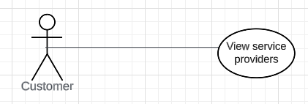

##### Figure: <Customer> View service providers

**Use Case Specification**

| **USE CASE - UC04** | | | |
| --- | --- | --- | --- |
| **Use Case No.** | **UC04** | **Use Case Version** | 1.1 |
| **Use Case Name** | View service providers | | |
| **Author** | Nguyen Ba Huy | | |
| **Date** | 17/06/2023 | **Priority** | Normal |
| **Actor:**  - Customer  **Summary:**  - This use case allows the user to view providers of a service in the system.  **Goal:**  - Customer can see the list of service providers.  **Trigger:**  - Customer clicks on one service from the service list in the homepage.  **Precondition:**  - Customer is on the home screen.  **Post Conditions:**  - Success: List of all providers of the service chosen will be displayed on screen.  **Main Success Scenario:**     | **Step** | **Actor Action** | **System Response** | | --- | --- | --- | | 1 | Customer clicks on one service from the service list in the homepage. | Show all providers of the service chosen including details:  . provider name  . provider service’s rating  . number of past bookings  . unit price  . service description |   **Relationship:** N/A.  **Business rule:**  o Display provider avatar when showing service provider.  o Display provider service details including:  . provider name  . provider service’s rating  . number of past bookings  . unit price  . service description | | | |

##### 

##### 

##### 

##### 

##### 

##### 

##### 

##### 

##### 

##### 

##### 

##### 

##### 

##### 

##### 

##### 

##### 

##### **3.2.2.2.** **<Customer> Place Booking**

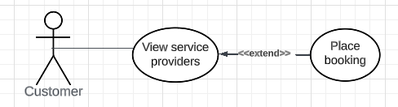

Figure: <Customer> Place Booking

| **USE CASE-05 SPECIFICATION** | | | | |
| --- | --- | --- | --- | --- |
| **Use-case No.** | UC05 | **Use-case Version** | | 1.1 |
| **Use-case Name** | Place Booking | | | |
| **Author** | Nguyen Hoang Nam, Nguyen Ba Huy | | | |
| **Date** | 17/06/2023 | **Priority** | High | |
| **Actor:**  Customer (primary), provider (secondary)  **Summary:**  A customer places a booking order after selecting a service provided by a provider.  **Goal:**  A customer can successfully send a booking placement request to the chosen provider  **Triggers**  A customer clicks the “Book” button on a service post.  **Preconditions:**  The customer must log in the system. The provider’s service must be available.  **Post Conditions:**  - Success: The customer successfully booked the service.  - Failure: The booking request is declined (timeout for 3 minutes or declined by the provider) and the customer is prompted to pick the service of another provider.  **Main Success Scenario:**     | Step | Actor Action | System Response | | --- | --- | --- | | 1 | Customers click on one service from the service list in the homepage. | Show all providers of the service chosen. | | 2 | Logged-in customer hits the “Book” button of one service provider to place the booking. | The system shows a count-down clock for 3 minutes waiting for the provider’s response. | | 3 | Customer gets notified of the booking response. | - If the provider accepts the booking, the counting clock will stop and a booking success message is displayed to the customer.  - If the provider actively declines the booking request of the clock counts timeout, a booking failure message is displayed to the customer and a new prompt for the service by another provider is displayed. |   **Alternative Scenario:**   | Step | Actor Action | System Response | | --- | --- | --- | | 1 | Logged-in customer hits the “Book Again” button of a service post that he/she has booked before in his/her booking history (re-booking) | The system shows a count-down clock for 3 minutes waiting for the provider’s response. | | 2 | Customer gets notified of the booking response. | - If the provider accepts the booking, the counting clock will stop and a booking success message is displayed to the customer.  - If the provider actively declines the booking request or the clock counts timeout, a booking failure message is displayed to the customer and a new prompt for the service by another provider is displayed. |     **Exceptions:**     | **Step** | **Cause** | **System Response** | | --- | --- | --- | | 1 | The customer cancels request during pending time | The count-down clock will stop and the customer is back to the current board and a cancellation message is displayed. | | 2 | The provider cancels the booking after accepting it | The system will notify the customer of the cancellation. The customer will then be brought to the board for other service articles by other providers.  The system increments red flag status on the canceling provider’s account. | | 3 | The customer hits “Book” button, but is not logged in. | The system will notify the customer “Please log in to place booking” and after 5 seconds redirect to the login page. After customer logins, the system will redirect to the “Current Activities” page for the customer to view their newest booking. |   **Relationships:** N/A  **Business Rules:**  - The pending time for booking requests is 3 minutes.  - If a booking request is successful, the system sends a confirmation email to both the customer and the provider.  - If the booking request fails, related articles of the same category by other providers are recommended.  - Upon accepting the booking, the provider is bound to show up at the customer’s location within 15 minutes. | | | | |

##### **3.2.2.3.** **<Customer> View booking history**

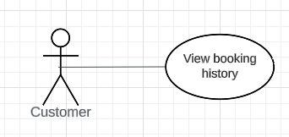

Figure: <Customer> View booking history

| **USE CASE-06 SPECIFICATION** | | | | |
| --- | --- | --- | --- | --- |
| **Use-case No.** | UC06 | **Use-case Version** | | 1.0 |
| **Use-case Name** | View booking history | | | |
| **Author** | Nguyen Ba Huy | | | |
| **Date** | 07/06/2023 | **Priority** | Normal | |
| **Actor:**  - Customer  **Summary:**  - This use case allows customer to view booking history  **Goal:**  - Customer can view booking history.  **Triggers:**  - Customer sends a view-booking-history command to the system.  **Preconditions:**  - Customer must login into the system with the role Customer.  **Post conditions:**  - Success: View the booking history successfully  **Main Success Scenario:**   | Step | Actor | System Response | | --- | --- | --- | | 1 | Customer clicks “Booking History” on navigation menu | System redirect to the booking history screen with a list of completed bookings of the customer with details about the booking:   1. Name of provider 2. Service and price 3. Booking Date |   **Alternative Scenario:**   | Step | Actor | System Response | | --- | --- | --- | | 1 | Customer is not logged in or their account is invalid | Customer is redirected to the login/registration page. |     **Exceptions**:     | No | Actor | System Response | | --- | --- | --- | | 1 | Customer does not have booking history | The system displays a message indicating that no bookings are available. | | 2 | The customer's login session expires during the process | They will be prompted to log in again before accessing their booking history |   **Relationships:** N/A  **Business Rules:**  - The system displays list of bookings based on customer’s id  - A booking must have:   1. Name of provider 2. Service and price 3. Booking Date | | | | |

##### 

##### **3.2.2.4.** **<Customer> View current activities**

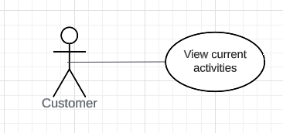

Figure: <Customer> View current activities

| **USE CASE-07 SPECIFICATION** | | | | |
| --- | --- | --- | --- | --- |
| **Use-case No.** | UC07 | **Use-case Version** | | 1.0 |
| **Use-case Name** | View current activities | | | |
| **Author** | Nguyen Ba Huy | | | |
| **Date** | 16/06/2023 | **Priority** | Normal | |
| **Actor:**  - Customer  **Summary:**  - This use case allows customer to view current activities  **Goal:**  - Customer can view current activities.  **Triggers:**  - Customer sends a view-current-activities command to the system.  **Preconditions:**  - Customer must login into the system with the role Customer.  **Post conditions:**  - Success: View the current activities successfully  **Main Success Scenario:**   | Step | Actor | System Response | | --- | --- | --- | | 1 | Customer clicks “Current Activities” on navigation menu | System redirect to the current activities screen with a list of current booking activities of the customer. | | 2 | Customer clicks on an activity | System redirect to current activity detail screen. Users can view all information details about the current booking activity:   1. Name of provider 2. Service and price 3. Booking Date 4. Status (confirmed by the provider or not) |   **Alternative Scenario:**   | Step | Actor | System Response | | --- | --- | --- | | 1 | Customer is not logged in or their account is invalid | Customer is redirected to the login/registration page. |     **Exceptions**:   | No | Actor | System Response | | --- | --- | --- | | 1 | Customer does not have current activities | The system displays a message indicating that no current activities are available. | | 2 | The customer's login session expires during the process | They will be prompted to log in again before accessing their booking history |   **Relationships:** N/A  **Business Rules:**  - Display list of current booking activities based on customer’s id  - A current booking activity must have:   1. Name of provider 2. Service and price 3. Booking Date 4. Status (confirmed by the provider or not) | | | | |

##### 

##### **3.2.2.5.** **<Customer> Cancel booking**

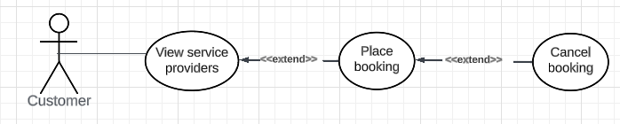

Figure: <Customer> Cancel booking

| **USE CASE - UC08** | | | |
| --- | --- | --- | --- |
| **Use Case No.** | **UC08** | **Use Case Version** | **1.0** |
| **Use Case Name** | **Cancel booking** | | |
| **Author** | **Nguyen Ba Huy** | | |
| **Date** | **16/06/2023** | **Priority** | **Normal** |
| **Actor:**- Customer**Summary:**- This use case allows customer to cancel service booking**Goal:**- Customer cancels booking successfully.**Triggers:**- Customer sends the cancel booking command to the system.**Preconditions:**- The user must login into the system with the role Customer.**Post conditions:**- Success: Booking was canceled successfully**Main Success Scenario:**  | **Step** | **Actor Action** | **System Response** | | --- | --- | --- | | **1** | Customer clicks “ Current Activity” on navigation menu | System redirect to the current activity screen with a list of current bookings of the customer. | | **2** | Customer clicks “Cancel” on one current booking. | System will show message “Booking Canceled” and return to current activity screen |  **Relationships:** View current activities**Business Rules:**· Status of booking will be changed to “Canceled” | | | |

##### **3.2.2.6.** **<Customer> Review booking**

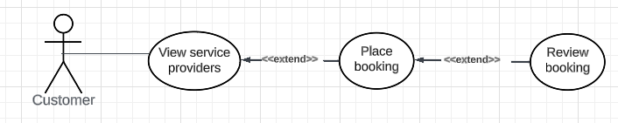

Figure: <Customer> Review booking

| **USE CASE - UC09** | | | |
| --- | --- | --- | --- |
| **Use Case No.** | **UC09** | **Use Case Version** | **1.0** |
| **Use Case Name** | **Review booking** | | |
| **Author** | **Nguyen Ba Huy** | | |
| **Date** | **16/06/2023** | **Priority** | **Normal** |
| **Actor:**- Customer**Summary:**- This use case allows customer to review and rate completed booking**Goal:**- Customer can review and rate booking successfully**Triggers:**- Customer clicks button “Review” of a booking article in the booking history screen.**Preconditions:**- Customer must login into the system with the role Customer.- Customer must use services and status of booking is “Completed”**Post conditions:**- Success: Review and rate booking successfully**Main Success Scenario:**  | **Step** | **Actor Action** | **System Response** | | --- | --- | --- | | **1** | Customer clicks “ Booking History” on the navigation menu. | System redirect to the booking history screen with a list of completed bookings of customers.[Exception 1] | | **2** | Customer clicks the button “Review”. | System redirect to review detail screen. | | **3** | Customer gives a comment and rates the booking then clicks the button “Submit”. | System will show a message “Review and Rate successfully” and return to the booking history screen. |  **Exception 1:**  | **No** | **Actor Action** | **System Response** | | --- | --- | --- | | **1** | Customer does not have bookings | The system displays a message indicating that no bookings are available. |  **Relationships: N/A.****Business Rules:**Customer must use services and status of booking is “Completed” | | | |

##### 

##### 

##### 

##### **3.2.2.7.** **<Customer> Chat**

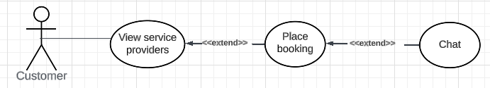

Figure: <Customer> Chat

| **USE CASE - UC10** | | | |
| --- | --- | --- | --- |
| **Use Case No.** | **UC10** | **Use Case Version** | **1.0** |
| **Use Case Name** | **Chat** | | |
| **Author** | **Nguyen Ba Huy** | | |
| **Date** | **16/06/2023** | **Priority** | **Normal** |
| **Actor:**- Customer**Summary:**- This use case allows customer to chat with the service provider**Goal:**- Customer can chat with the service provider successfully**Triggers:**- Customer clicks the “Chat” button on one booking in the current activity screen.**Preconditions:**- Customer must login into the system with the role Customer.- Customer must place booking and status of booking is “Order Confirmed By Provider” or “Completed”**Post conditions:**- Success: Chat with the service provider successfully**Main Success Scenario:**  | **Step** | **Actor Action** | **System Response** | | --- | --- | --- | | **1** | Customer clicks “ Current Activity” on navigation menu | System redirect to the current activity screen with a list of current bookings of the customer. (Exception 1) | | **2** | Customer clicks “Chat” on one current booking. | System will open a chat box for the customer to chat with the provider of the current booking. | | **3** | Customer types chat messages and hits “Send” to send messages to the provider. | System will send messages of the customer to the provider. At the same time, the system will show the messages sent by the provider in the chat box. |  **Exception 1:**  | **No** | **Actor Action** | **System Response** | | --- | --- | --- | | **1** | Customer does not have current activities | The system displays a message indicating that no activities are available. |  **Relationships:** View current activities**Business Rules:**- Customer must place booking and status of booking is “Processing” or “Completed” | | | |

##### 

##### **3.2.2.8.** **<Customer> View chat history**

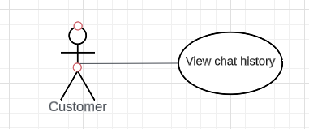

Figure: <Customer> View chat history

| **USE CASE-11 SPECIFICATION** | | | | |
| --- | --- | --- | --- | --- |
| **Use-case No.** | UC11 | **Use-case Version** | | 1.0 |
| **Use-case Name** | View chat history | | | |
| **Author** | Nguyen Ba Huy | | | |
| **Date** | 07/06/2023 | **Priority** | Normal | |
| **Actor:**  - Customer  **Summary:**  - This use case allows customer to view chat history  **Goal:**  - Customer can view chat history.  **Triggers:**  - Customer sends a view-chat-history command to the system.  **Preconditions:**  - Customer must login into the system with the role Customer.  **Post conditions:**  - Success: View chat history successfully  **Main Success Scenario:**   | Step | Actor | System Response | | --- | --- | --- | | 1 | Customer clicks “Chat History” on navigation menu | System redirect to the chat history screen with a list of chats of the customer. | | 2 | Customer clicks on a chat | System will open a chat box for the customer to view messages in the past and continue to chat with the provider. | | 3 | Customer types chat messages and hits “Send” to send messages to the provider. | System will send messages of the customer to the provider. At the same time, the system will show the messages sent by the provider in the chat box. |   **Alternative Scenario:**   | Step | Actor | System Response | | --- | --- | --- | | 1 | Customer is not logged in or their account is invalid | Customer is redirected to the login/registration page. |     **Exceptions**:     | No | Actor | System Response | | --- | --- | --- | | 1 | Customer does not have chats | The system displays a message indicating that no chats are available. | | 2 | The customer's login session expires during the process | They will be prompted to log in again before accessing chat. |   **Relationships:** N/A  **Business Rules:**  - Display list of chats based on customer’s id | | | | |

##### 

##### **3.2.2.9.** **<Customer> Logout**

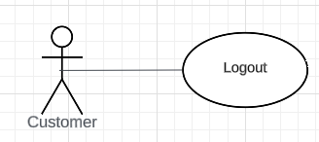

Figure: <Customer> Logout

| **USE CASE - UC12** | | | |
| --- | --- | --- | --- |
| **Use Case No.** | **UC12** | **Use Case Version** | 1.1 |
| **Use Case Name** | Logout | | |
| **Author** | Nguyen Ba Huy | | |
| **Date** | 16/06/2023 | **Priority** | Normal |
| **Actor:**  - Customer  **Summary:**  - This use case allows the customer to logout to the system.  **Goal:**  - Customer can logout from the system  **Trigger:**  - Customer sends a logout command.  **Precondition:**  - Customer must log in before logging out.  **Post Conditions:**  - Success: Customer logout to the system successfully  **Main Success Scenario:**     | **Step** | **Actor Action** | **System Response** | | --- | --- | --- | | 1 | Customer clicks “Logout” on the navigation menu. | Return the user to the home screen. |       **Relationship:** N/A.  **Business rule:**   * After logged out, user access the system as role “Customer” * Return the user to the home screen after logged out. | | | |

##### **3.2.2.10. <Customer> Update account information**

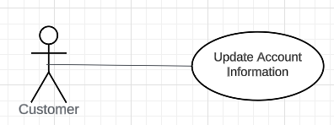

Figure: <Customer> Update account information

| **USE CASE-13 SPECIFICATION** | | | | |
| --- | --- | --- | --- | --- |
| **Use-case No.** | UC13 | **Use-case Version** | | 1.0 |
| **Use-case Name** | Update account information | | | |
| **Author** | Nguyen Ba Huy | | | |
| **Date** | 17/06/2023 | **Priority** | Normal | |
| **Actor:**  - Customer  **Summary:**  - This use case allows customer to update their account information  **Goal:**  - Customer can update their account information.  **Triggers:**  - Customer sends an update account information command to the system.  **Preconditions:**  - Customer must login into the system with the role Customer.  **Post conditions:**  - Success: update the account information successfully  **Main Success Scenario:**   | Step | Actor | System Response | | --- | --- | --- | | 1 | Customer clicks “Account” on navigation menu | System redirect to the account screen with account information of the customer. | | 2 | Customer clicks on “Update” button | System show a form pop-up for the customer to fill in details:   1. Name of customer 2. Email 3. Phone | | 3 | Customer fills in details (name, email, phone) and hits the “Submit” button. | System will show the message “Update account information successfully” and return to the account screen. |   **Alternative Scenario:**   | Step | Actor | System Response | | --- | --- | --- | | 1 | Customer is not logged in or their account is invalid | Customer is redirected to the login/registration page. |     **Exceptions**:     | No | Actor | System Response | | --- | --- | --- | | 1 | The customer's login session expires during the process | They will be prompted to log in again before accessing their booking history |   **Relationships:** N/A  **Business Rules:**  - Display customer’s information based on customer’s id  - Customer’s account information must have:   1. Name of customer 2. Email 3. Phone | | | | |

#### 

#### **3.2.3.** **<Provider> Overview Use Case**

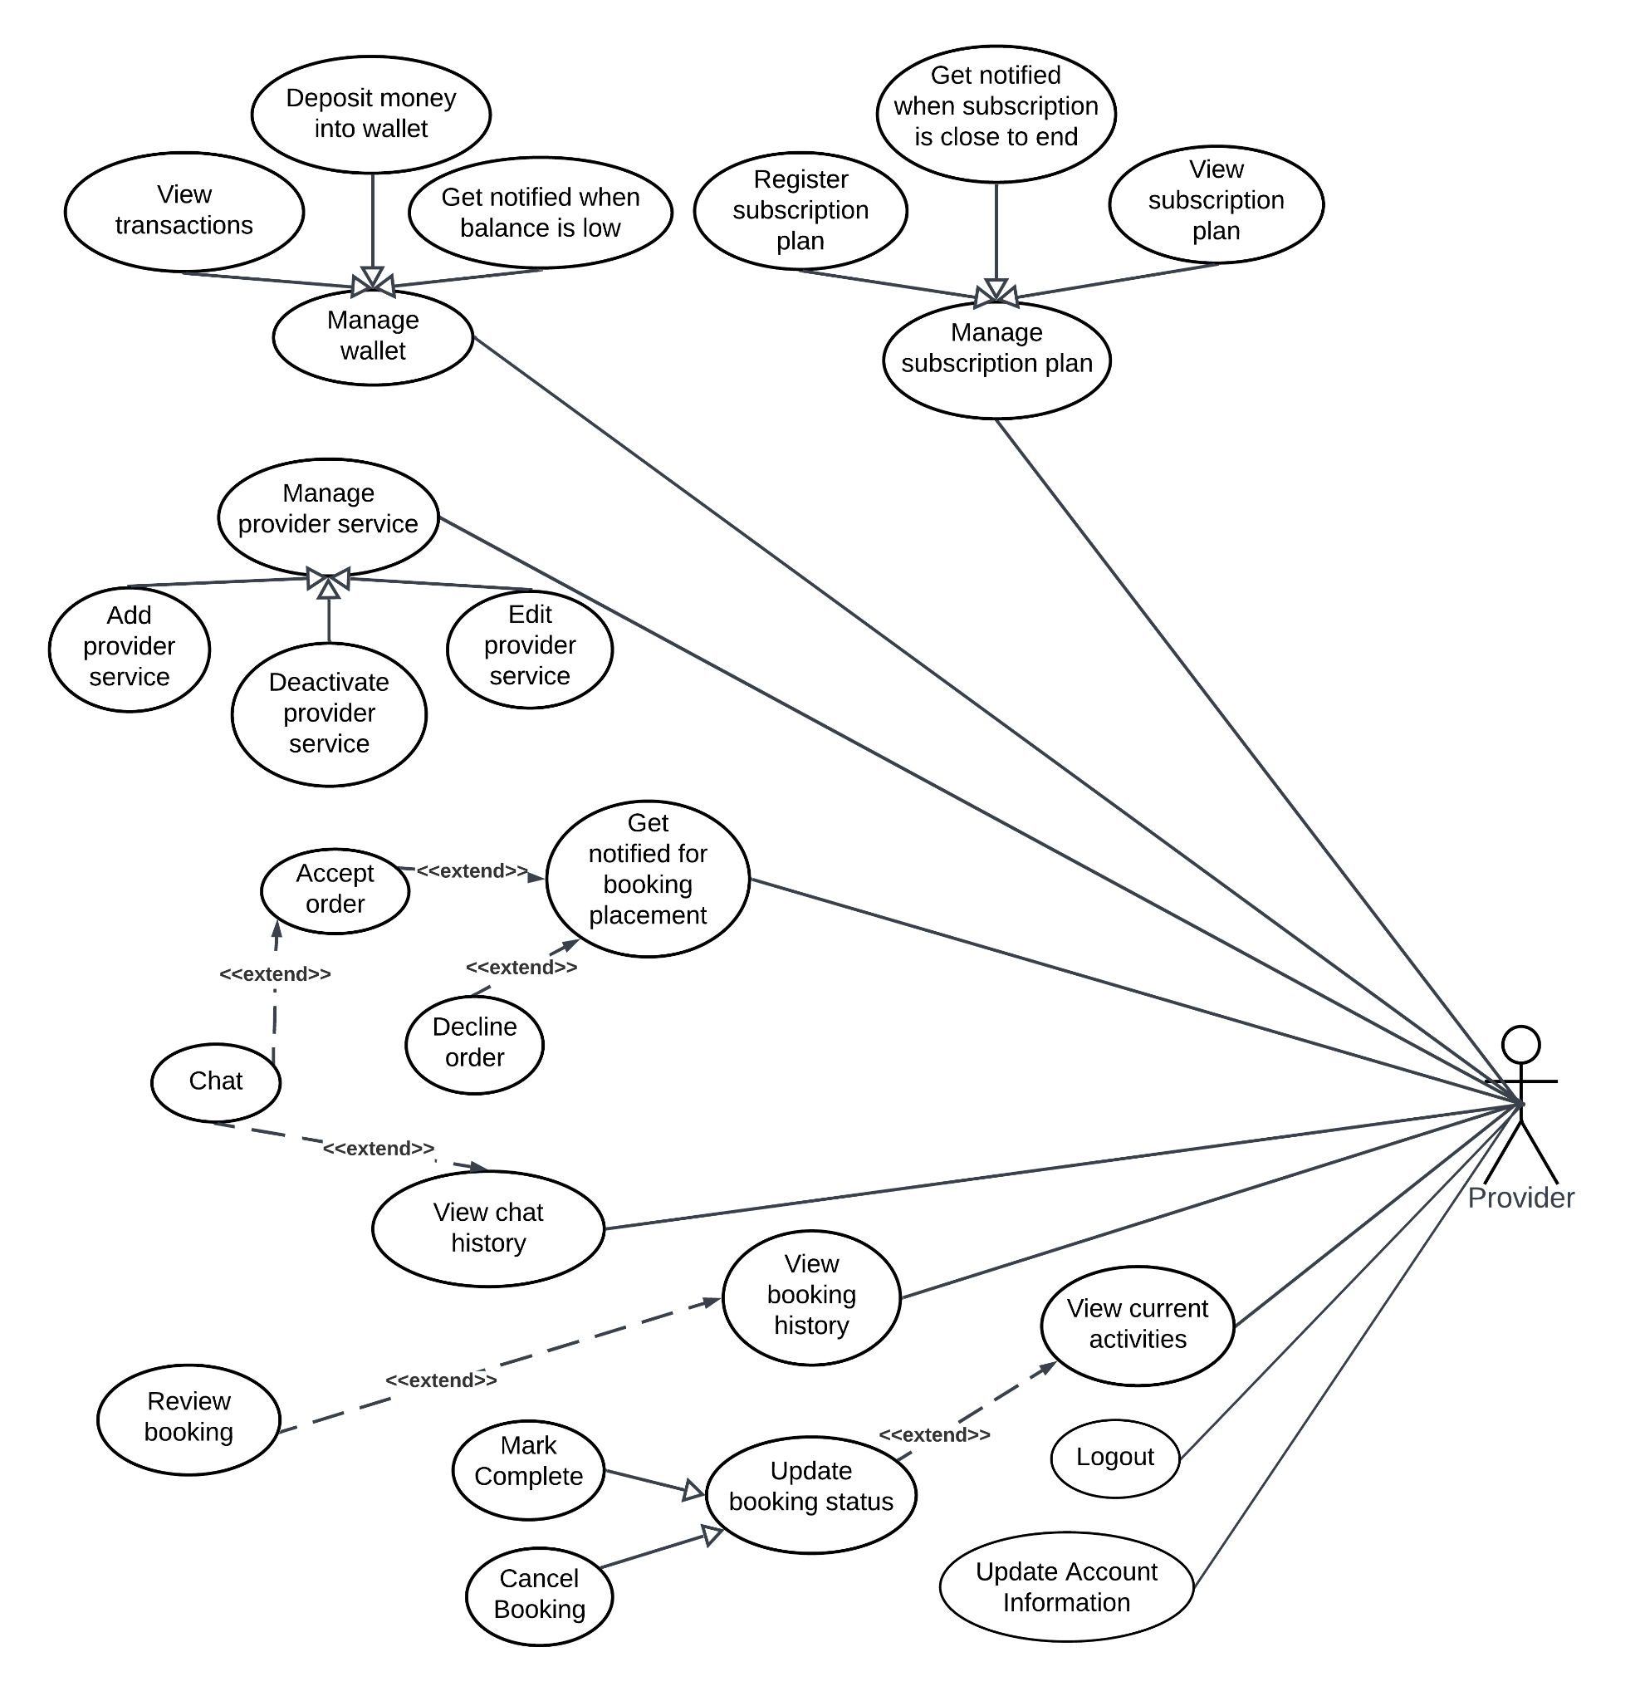

Figure: <Provider> Overview use case

##### **3.2.3.1. <Provider> View current activities**

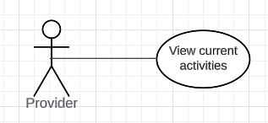

Figure: <Provider> View current activities

| **USE CASE – UC_14** | | | |
| --- | --- | --- | --- |
| **Use Case No.** | **UC_14** | **Use Case Version** | 2.0 |
| **Use Case Name** | View current activities | | |
| **Author** | Nguyen Hoang Nam | | |
| **Date** | 17/06/2023 | **Priority** | High |
| **Actor:**   * Provider (primary), system (secondary)   **Summary:**   * This use case allows a provider to view his on-going activities like pending bookings or working bookings.   **Goal:**   * Provider successfully views his on-going activities   **Triggers:**   * Provider clicks “ Current Activity” tab on nav bar   **Preconditions:**   * User must login to the system as provider * Provider account is active in the system   **Post conditions:**   * Success:   Provider successfully views his list of current bookings categorized into different groups (Pending/Working)   * Fail: Show error message of booking retrieval failure   **Main Success Scenario:**   | **Step** | **Actor Action** | **System Response** | | --- | --- | --- | | 1 | User logins as provider | Activate provider’s availability status and displays main view board for provider | | 2 | Clicks on the "Current Activities" tab option | Display a full list of current activities categorized into groups. The booking details include:   * Customer name * Provider service name and ID * Building name * Apartment * Unit price * Status | | 3 | Provider can click buttons available in on-going bookings to update the status of those bookings and carry other tasks | Update the status of current bookings and walk customer to other tasks |   **Exceptions:**   | **No** | **Cause** | **System Response** | | --- | --- | --- | | 1 | Page of current activities is attempted to be retrieved even when the provider is not logged in (no authentication) | System shows a message with authentication and walks the user to the login page. |   **Relationships:** N/A  **Business Rules:**   * Provider can view full details of current bookings. * Categories include:   + Pending bookings: waiting for provider’s response (decline or accept).   + Working bookings: the task that the provider is completing. | | | |

##### 

##### **3.2.3.2. <Provider> Get notified for booking placement**

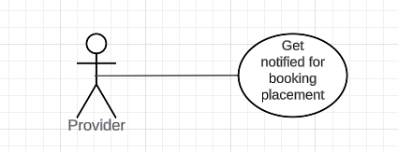

Figure: <Provider> Get notified for booking placement

| **USE CASE – UC_15** | | | |
| --- | --- | --- | --- |
| **Use Case No.** | **UC_15** | **Use Case Version** | 2.0 |
| **Use Case Name** | Get notified for booking placement | | |
| **Author** | Nguyen Hoang Nam | | |
| **Date** | 17/06/2023 | **Priority** | High |
| **Actor:**   * Provider (primary), customer(secondary), system (secondary)   **Summary:**   * This use case allows a provider to get notified in case some customer places a booking of his service.   **Goal:**   * Provider successfully receives a notification for his new booking placement.   **Triggers:**   * Customer clicks on the button “Book” on the post of the provider service.   **Preconditions:**   * User must login to the system as provider * Provider account is active in the system * The customer books a booking of the provider’s available services.   **Post conditions:**   * Success:   Provider successfully views his list of current categories categorized into different groups (Pending/Working)   * Fail: Show error message of booking retrieval failure   **Main Success Scenario:**   | **Step** | **Actor Action** | **System Response** | | --- | --- | --- | | 1 | User logins as provider | Activate provider’s availability status and displays main view board for provider | | 2 | Clicks on the "Current Activities" tab option | Display full list of current activities categorized into groups | | 3 | Provider can click buttons available in on-going bookings to update the status of those bookings and carry other tasks | Update the status of current bookings and walk customer to other tasks |   **Exceptions:**   | **No** | **Cause** | **System Response** | | --- | --- | --- | | 1 | Page of current activities is attempted to be retrieved even when the provider is not logged in (no authentication) | System shows a message with authentication and walks the user to the login page. |   **Relationships:** Place booking by a customer  **Business Rules:**   * Provider can view full details of current bookings. * Categories include:   + Pending bookings: waiting for provider’s response (decline or accept).   + Working bookings: the task that the provider is completing. | | | |

##### 

##### **3.2.3.3. <Provider> Accept booking request**

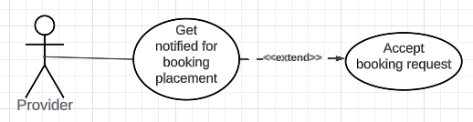

Figure: <Provider> Accept booking request

| **USE CASE – UC_16** | | | |
| --- | --- | --- | --- |
| **Use Case No.** | **UC_16** | **Use Case Version** | 2.0 |
| **Use Case Name** | Accept booking request | | |
| **Author** | Nguyen Hoang Nam | | |
| **Date** | 17/06/2023 | **Priority** | High |
| **Actor:**   * Provider (primary), customer(secondary), system (secondary)   **Summary:**   * This use case allows a provider to accept a booking request after being notified of its placement by a customer.   **Goal:**   * Provider successfully accepts the booking from a customer.   **Triggers:**   * Provider clicks on the “Accept” button on the notification pop-up message upon the booking placement of a customer.   **Preconditions:**   * User must login to the system as provider * Provider account is active in the system * A booking of the provider’s available services has been placed.   **Post conditions:**   * Success:   Provider successfully accepts his booking   * Fail: Show error message of failure in accepting the booking.   **Main Success Scenario:**   | **Step** | **Actor Action** | **System Response** | | --- | --- | --- | | 1 | User logins as provider | Activate provider’s availability status and displays main view board for provider | | 2 | Clicks notification icon on his nav bar | Display list of latest notifications including the booking placement of his service. | | 3 | Provider clicks the specific notification of the service being booked | The system displays the details of the booking, including:   * Customer Name * Provider Service name * Building * Apartment * Unit price * Date and time * with 2 options “Accept” and “Decline”. | | 4 | Provider clicks on the button “Accept” within the time remaining | * The system updates the status of the booking to ACCEPTED and moves this booking to the “Current Activities” page of both the provider and the customer. * The system switches the availability status of the provider off until the completion of such a task. This hides all the services of this provider from the board of services visible to customers. * The system automatically generates a booking fee account on the provider’s wallet, which results in a subtraction to his balance. The transaction is recorded in the database, and can be retrieved in the provider’s transaction history. * From the customer’s view, the clock counting down will stop and a successful acceptance message pops up to notify the customer of the booking acceptance. * The current position of the provider is displayed in the corresponding booking in the “Current Activity page”. The customer is allowed to book other services upon this. |   **Alternative Scenario**   | **Step** | **Actor** | **System Response** | | --- | --- | --- | | 1 | The provider accesses his email account and checks the notification for a new booking placement. |  | | 2 | The provider clicks on the link to pending booking for further action | Ask the provider to log in upon the access of the application  Upon successful authentication, bring the provider to the waiting booking on the “Current Activities” page. | | 3 | Similar to step 3 of the main scenario | | | 4 | Similar to step 3 of the main scenario | |   **Exceptions:**   | **No** | **Cause** | **System Response** | | --- | --- | --- | | 1 | Page of current activities is attempted to be retrieved even when the provider is not logged in (no authentication) | System shows a message with authentication and walks the user to the login page. | | 2 | System fails to update the working bookings | System shows a message with an internal exception and the booking is marked DECLINED automatically. The system will then ask the customer to rebook another service. | | 3 | The provider does not respond to the booking request or hit the “Accept” button in the last seconds and the network connection fails to catch up with the countdown clock on the customer side | The system will notice the customer of the decline of his/her booking. The status of such a booking will be set DECLINED and the provider cannot accept or decline it anymore.  A recommendation of similar service by other providers is displayed on the customer’s screen. |   **Relationships:** Get notified of a new booking  **Business Rules:**   * The countdown time for a booking request is 3 minutes, which equates to the allowance time for the customer to accept a booking, disregarding latencies or network glitches. * If the provider does not respond to a booking within countdown time, the system automatically marks such booking DECLINED and moves the booking to the booking history. No booking fee is charged for this circumstance. * The current position of the provider is updated constantly on the customer’s screen upon booking acceptance to give some hints of where the provider is. * The provider should strive to arrive at the destination within 15 minutes and complete his task satisfactorily. | | | |

##### 

##### **3.2.3.4. <Provider> Decline booking request**

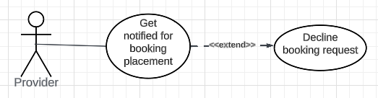

Figure: <Provider> Decline booking request

| **USE CASE – UC_17** | | | |
| --- | --- | --- | --- |
| **Use Case No.** | **UC_17** | **Use Case Version** | 2.0 |
| **Use Case Name** | Decline booking request | | |
| **Author** | Nguyen Hoang Nam | | |
| **Date** | 17/06/2023 | **Priority** | High |
| **Actor:**   * Provider (primary), customer(secondary), system (secondary)   **Summary:**   * This use case allows a provider to decline a booking request after being notified of its placement by a customer.   **Goal:**   * Provider successfully declines the booking from a customer.   **Triggers:**   * Provider clicks on the “Decline” button on the notification pop-up message upon the booking placement of a customer.   **Preconditions:**   * User must login to the system as provider * Provider account is active in the system * A booking of the provider’s available services has been placed.   **Post conditions:**   * Success:   Provider successfully declines a booking   * Fail: Show error message of failure in declining the booking.   **Main Success Scenario:**   | **Step** | **Actor Action** | **System Response** | | --- | --- | --- | | 1 | User logins as provider | Activate provider’s availability status and displays main view board for provider | | 2 | Clicks notification icon on his nav bar | Display list of latest notifications including the booking placement of his service. | | 3 | Provider clicks the specific notification of the service being booked | The system displays the details of the booking, including:   * Customer Name * Provider Service name * Building, apartment * Unit price * Date and time * With 2 options “Accept” and “Decline”. | | 4 | Provider clicks on the button “Decline” within the time remaining | A confirmatory popup message appears, asking “Are you sure to decline this booking?” with 2 options: “Yes” and “No”. | | 5 | Provider clicks on the button “Yes” | * The system updates the status of the booking to DECLINED and moves this booking to the “Current Activities” page of both the provider and the customer. * A message of decline is displayed on the provider's screen and he is brought back to the home page. * The system will switch the availability status of the system off for 15 minutes; therefore, he will not be visible on customers’ screens for such a time interval. * The countdown clock is collapsed and an apology message is displayed on the customer’s screen, signifying the decline of the booking. A recommended alternative list is displayed for the same service by other providers. |   **Alternative Scenario**   | **Step** | **Actor** | **System Response** | | --- | --- | --- | | 1 | The provider accesses his email account and checks the notification for a new booking placement. |  | | 2 | The provider clicks on the link to pending booking for further action | Ask the provider to log in upon the access of the application  Upon successful authentication, bring the provider to the waiting booking on the “Current Activities” page, with details including the Customer Name, Provider Service name, building, apartment, unit price, date and time with 2 options “Accept” and “Decline”. | | 3 | Similar to step 4 of the main scenario | | | 4 | Similar to step 5 of main scenario | |   **Exceptions:**   | **No** | **Cause** | **System Response** | | --- | --- | --- | | 1 | Page of current activities is attempted to be retrieved even when the provider is not logged in (no authentication) | System shows a message with authentication and walks the user to the login page. | | 2 | System fails to update the working bookings | System shows a message with an internal exception and the booking is marked DECLINED automatically. The system will then ask the customer to rebook another service. | |  |  |  |   **Relationships:** Get notified of a new booking  **Business Rules:**   * The countdown time for a booking request is 3 minutes, which equates to the allowance time for the customer to accept a booking, disregarding latencies or network glitches. * If the provider does not respond to a booking within countdown time, the system automatically marks such booking DECLINED and moves the booking to the booking history. No booking fee is charged for this circumstance. * The decline of the provider is a negative event, which results in a 15-minute unavailability status on the provider’s profile and the prompt for other options of the same service for the declined customer. * The DECLINED status of the booking does not allow any reviews of ratings from either side. This item is still visible in the booking history of both. | | | |

##### 

##### **3.2.3.5. <Provider> Mark Complete a Booking (Update booking status)**

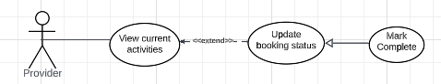

Figure: <Provider> Mark Complete a Booking (Update booking status)

| **USE CASE – UC_18** | | | |
| --- | --- | --- | --- |
| **Use Case No.** | **UC_18** | **Use Case Version** | 2.0 |
| **Use Case Name** | Mark Complete a Booking (Update booking status) | | |
| **Author** | Nguyen Hoang Nam | | |
| **Date** | 17/06/2023 | **Priority** | High |
| **Actor:**   * Provider (primary), system (secondary)   **Summary:**   * This use case allows a provider to mark the completion of bookings in their status on the ‘Current Activity’ page of a provider.   **Goal:**   * Provider successfully marks complete the status of a booking upon the finish of his work.   **Triggers:**   * Provider completes his practical tasks. * Provider hits the “Complete” button on the working bookings   **Preconditions:**   * User must login to the system as provider * Providers must have on-going working bookings. * Provider should complete his task in real life.   **Post conditions:**   * Success:   Provider successfully updates the completion status of his working bookings   * Fail: Show error message of failure of updating booking status   **Main Success Scenario:**   | **Step** | **Actor Action** | **System Response** | | --- | --- | --- | | 1 | Clicks on the "Current Activities" tab option | Display full list of current activities | | 2 | Navigate to working bookings, provide optional information like the total amount (for statistics). | Save additional information for further sum-up statistics at the end of each month | | 3 | Hit the button “Complete” in the lower right corner | Update the completion status of the booking and switch the availability status of the provider back on so that he will appear on the board of customers |   **Exceptions:**   | **No** | **Cause** | **System Response** | | --- | --- | --- | | 1 | Provider gives the wrong format of total amount, which should be long. | System shows a message with incorrect format and prompts the provider to retry | | 2 | User tries to retrieve the working bookings without logging in | System shows a message with authentication and walks the user to the login page. | | 3 | System fails to update the working bookings | System shows a message with an internal exception and asks the provider to come back later. |   **Relationships:** View current activities  **Business Rules:**   * Logged in provider can update the status of his working bookings upon completion in real life. During the working status of the provider, his availability will be automatically switched off, hiding him away from the search view of customers. * Updating the completion status of the working bookings activates the provider’s availability. The provider can give additional information, like the total amount earned for further statistics at the end of the month for revenue sum-up. | | | |

##### 

##### **3.2.3.6. <Provider> Cancel a Booking (Update booking status)**

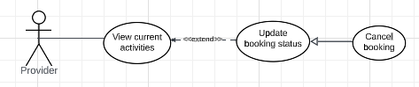

Figure: <Provider> Cancel a Booking (Update booking status)

| **USE CASE – UC_19** | | | |
| --- | --- | --- | --- |
| **Use Case No.** | **UC_19** | **Use Case Version** | 2.0 |
| **Use Case Name** | Cancel a Booking (Update booking status) | | |
| **Author** | Nguyen Hoang Nam | | |
| **Date** | 17/06/2023 | **Priority** | High |
| **Actor:**   * Provider (primary), system (secondary)   **Summary:**   * This use case allows a provider to cancel a booking on the ‘Current Activity’ page of a provider.   **Goal:**   * Provider successfully cancels a booking after accepting it.   **Triggers:**   * Provider hits the “Cancel” button on the working bookings in his current activities   **Preconditions:**   * User must login to the system as provider * Providers must have on-going working bookings. * Provider may fail to assume his job.   **Post conditions:**   * Success:   Provider successfully cancels a booking.   * Fail: Show error message of failure of updating booking status.   **Main Success Scenario:**   | **Step** | **Actor Action** | **System Response** | | --- | --- | --- | | 1 | Clicks on the "Current Activities" tab option | Display full list of current activities | | 2 | Navigate to working bookings, hit the “Cancel” button on the current activities that he fails to complete. | Prompt a pop-up warning that the cancellation will mark a red flag in the provider’s credibility. A popup window for confirmation appears with the “Confirm” and “Discard” option. | | 3 | Hit the button “Confirm” button | * Update the status of such booking, bringing it to the booking history of both and freeze the unavailability status of the provider for 1 hour. * The system increments the cancellation red flag on the provider’s profile as the basis for account suspension. * The canceled customer is notified with the cancellation of his/her booking and is encouraged to pick another provider * The system allows customers and providers to leave review and rating on the canceled bookings. |   **Exceptions:**   | **No** | **Cause** | **System Response** | | --- | --- | --- | | 1 | User tries to retrieve the working bookings without logging in | System shows a message with authentication and walks the user to the login page. | | 2 | System fails to update the working bookings | System shows a message with an internal exception and asks the provider to come back later. |   **Relationships:** View current activities  **Business Rules:**   * Logged in provider can cancel a booking if he fails to fulfill it upon his acceptance. This action increments his cancellation red flag count, the threshold of which is 5 times per month. Passing this cutoff point results in account suspension. * The cancellation of a booking is a negative event, which disables the provider’s availability for 1 hour and prompts the customers for alternative option repicks. * The provider and customer of such booking is allowed to leave reviews and ratings for their reasons and complaints. This counts to the overall rating of the provider himself and his provider service. | | | |

##### **3.2.3.7.** **<Provider> Chat**

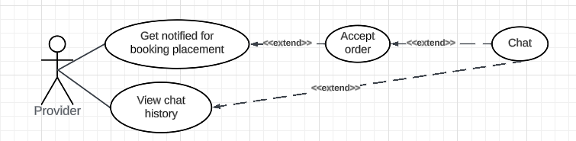

Figure: <Provider> Chat

| **USE CASE - UC20** | | | |
| --- | --- | --- | --- |
| **Use Case No.** | **UC20** | **Use Case Version** | **1.0** |
| **Use Case Name** | **Chat** | | |
| **Author** | **Nguyen Ba Huy** | | |
| **Date** | **16/06/2023** | **Priority** | **Normal** |
| **Actor:**- Provider**Summary:**- This use case allows the service provider to chat with the customers upon the booking acceptance.**Goal:**- The provider can proceed to chat with the customers upon accepting the booking placed by them.**Triggers:**- Provider clicks the “Chat” button on one booking in the current activity screen or clicks on the booking to chat on the chat history page.**Preconditions:**- Provider must login into the system with the role Provider.- Provider must accept the booking request and the status of booking is ACCEPTED.**Post conditions:**- Success: The provider successfully chats with the customer.**Main Success Scenario:**  | **Step** | **Actor Action** | **System Response** | | --- | --- | --- | | **1** | Provider clicks “ Current Activity” on navigation menu | System redirect to the current activity screen with a list of current bookings. (Exception 1) | | **2** | Provider clicks “Chat” on one current booking. | System will open a chat box for the provider to chat with the customer of the current booking. | | **3** | Provider types chat messages and hits “Send” to send messages to the customer. | System will send messages of the provider to the customer.. At the same time, the system will show the messages sent by the customer in the chat box. |  **Exception 1:**  | **No** | **Actor Action** | **System Response** | | --- | --- | --- | | **1** | Provider does not have current activities. | The system displays a message indicating that no activities are available. |  **Relationships:** View current activities**Business Rules:**- The provider can chat with customers, the booking of whom has been accepted by the provider. To start the chat, the status of booking must be ACCEPTED. - The messages sent are not subject to modification neither by the provider, the customer nor the admin. The background worker of the system will periodically remove messages older than 3 months.  - The customer and provider can retrieve their recent chats in the chat history. The content of the conversation should revolve around the booking being completed and no private contact is expected to be disclosed. | | | |

##### 

##### **3.2.3.8.** **<Provider> View chat history**

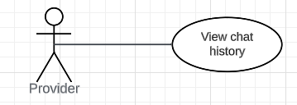

Figure: <Provider> View chat history

| **USE CASE-21 SPECIFICATION** | | | | |
| --- | --- | --- | --- | --- |
| **Use-case No.** | UC21 | **Use-case Version** | | 1.0 |
| **Use-case Name** | View chat history | | | |
| **Author** | Nguyen Ba Huy | | | |
| **Date** | 17/06/2023 | **Priority** | Normal | |
| **Actor:**  - Provider  **Summary:**  - This use case allows provider to view chat history  **Goal:**  - Provider can view chat history.  **Triggers:**  - Provider sends a view-chat-history command to the system.  **Preconditions:**  - Provider must login into the system with the role Provider.  **Post conditions:**  - Success: View chat history successfully  **Main Success Scenario:**   | Step | Actor | System Response | | --- | --- | --- | | 1 | Provider clicks “Chat History” on navigation menu | System redirect to the chat history screen with a list of chats of the provider. | | 2 | Provider clicks on a chat | System will open a chat box for the provider to view messages in the past and continue to chat with the customer. | | 3 | Provider types chat messages and hits “Send” to send messages to the customer. | System will send messages of the provider to the customer. At the same time, the system will show the messages sent by the customer in the chat box. |   **Alternative Scenario:**   | Step | Actor | System Response | | --- | --- | --- | | 1 | Provider is not logged in or their account is invalid | Provider is redirected to the login/registration page. |     **Exceptions**:     | No | Actor | System Response | | --- | --- | --- | | 1 | Provider does not have chats | The system displays a message indicating that no chats are available. | | 2 | The provider's login session expires during the process | They will be prompted to log in again before accessing chat. |   **Relationships:** N/A  **Business Rules:**  - Display list of chats based on provider’s id | | | | |

##### 

##### **3.2.3.9. <Provider> View Booking History**

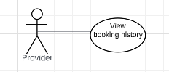

Figure: <Provider> View Booking History

| **USE CASE – UC_22** | | | |
| --- | --- | --- | --- |
| **Use Case No.** | **UC_22** | **Use Case Version** | 2.0 |
| **Use Case Name** | View booking history | | |
| **Author** | Nguyen Hoang Nam | | |
| **Date** | 17/06/2023 | **Priority** | High |
| **Actor:**   * Provider (primary), system (secondary)   **Summary:**   * This use case allows a provider to view his booking history, including completed, declined, and canceled bookings.   **Goal:**   * Provider successfully views his booking history categorized by status types and sorted by time.   **Triggers:**   * Provider clicks “Booking History” tab on nav bar   **Preconditions:**   * User must login to the system as provider * Provider account is active in the system   **Post conditions:**   * Success:   Provider successfully views his list of history bookings categorized by status: declined, completed, and canceled and sorted by time.   * Fail: Show error message of booking history retrieval failure   **Main Success Scenario:**   | **Step** | **Actor Action** | **System Response** | | --- | --- | --- | | 1 | User logins as provider | Activate provider’s availability status and displays main view board for provider | | 2 | Clicks on the "Booking History" tab option | Display full list of history bookings categorized by status and sorted by time | | 3 | Provider can filter bookings by date and by status: completed/canceled/declined button | Returns list of bookings fitting the filters, including information:   * Customer name * Provider service name and ID * Building name, apartment * Unit price and total * Rating by provider and customer * Review by customer and provider * Status |   **Exceptions:**   | **No** | **Cause** | **System Response** | | --- | --- | --- | | 1 | Page of current activities is attempted to be retrieved even when the provider is not logged in (no authentication) | System shows a message with authentication and walks the user to the login page. |   **Relationships:** N/A  **Business Rules:**   * Provider can view full details of history bookings. * Booking status:   + Canceled: bookings canceled (not able to complete) by provider upon his acceptance.   + Declined: booking placements refused by provider   + Completed: bookings completed by provider. * Provider cannot delete or create new entries in booking history nor the current activity. System’s background worker will periodically remove booking history older than 3 months. * Providers can only update the total amount and leave rating, review (for statistics purpose only) in the booking history. | | | |

##### 

##### **3.2.3.10. <Provider> Review Booking**

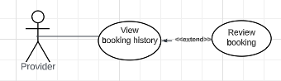

Figure: <Provider> Review Booking

| **USE CASE – UC_23** | | | |
| --- | --- | --- | --- |
| **Use Case No.** | **UC_23** | **Use Case Version** | 2.0 |
| **Use Case Name** | Review Booking | | |
| **Author** | Nguyen Hoang Nam | | |
| **Date** | 17/06/2023 | **Priority** | High |
| **Actor:**   * Provider (primary), system (secondary)   **Summary:**   * This use case allows a provider to review and rate the customer of a completed booking in the booking history.   **Goal:**   * Provider successfully reviews and rates the customer of a completed booking in booking history.   **Triggers:**   * Provider clicks “Review” button on a completed booking in booking history   **Preconditions:**   * User must login to the system as provider * Provider account is active in the system * The booking to be reviewed must be completed   **Post conditions:**   * Success:   Provider successfully adds review and rating to a completed booking, which subsequently updates the overall rating of the corresponding customer.   * Fail: Show error message of failure to add review/rating   **Main Success Scenario:**   | **Step** | **Actor Action** | **System Response** | | --- | --- | --- | | 1 | User logins as provider | Activate provider’s availability status and displays main view board for provider | | 2 | Clicks on the "Booking History" tab option | Display full list of history bookings categorized by status and sorted by time | | 3 | Provider selects a booking to review and hits “Review” button | The system displays the full details of selected booking, including:   * Customer name * Provider service name * Building name, apartment * Unit price, total * Date * Input field for review along with number of stars for rating. | | 4 | Provider selects a number of stars (from 1 to 5) for rating and enters review in the text box or attaches an image if he wishes to. Provider then hits “Save” button on the booking being reviewed. | * System automatically saves the rating and review of the booking into the system. These items will be displayed in the details of a provider service. * The image would be forwarded and saved in Firebase storage, the result of which, a link to the image, is then saved in the system’s database. * The system will recalculate the average rating of the corresponding customer by averaging the ratings of bookings by such customer. * A success message is sent to the provider and he will be back on the page for booking details being reviewed. |   **Exceptions:**   | **No** | **Cause** | **System Response** | | --- | --- | --- | | 1 | Provider inputs a review longer than max length of the box | System shows a message warning the excessive length of the review |   **Relationships:** View Booking History  **Business Rules:**   * The provider can only rate and review a booking that has been completed (status: COMPLETED). Otherwise, the option for review is disabled. * The rating scale includes integers from 1 to 5 * The provider can review without rating and vice versa or can do both. * The max length for review is 1500 characters * The image of relevant content can be uploaded from the local machine of the provider * The reviews will be displayed in the response portion of the review section of the corresponding provider service. The rating serves the purpose of calculating the overall rating of a customer. | | | |

##### 

##### **3.2.3.11. <Provider> Add Provider Service**

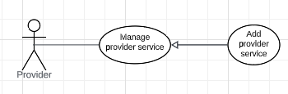

Figure: <Provider> Add Provider Service

| **USE CASE – UC_24** | | | |
| --- | --- | --- | --- |
| **Use Case No.** | **UC_24** | **Use Case Version** | 2.0 |
| **Use Case Name** | Add Provider Service | | |
| **Author** | Nguyen Hoang Nam | | |
| **Date** | 17/06/2023 | **Priority** | High |
| **Actor:**   * Provider (primary), system (secondary)   **Summary:**   * This use case allows a provider to add a provider service of one of available services in the system.   **Goal:**   * Provider successfully creates a new provider service and could be accessed in his service main page from both provider and customer view.   **Triggers:**   * Provider clicks “Create Service” in the provider service form after filling required fields.   **Preconditions:**   * User must login to the system as provider * Provider account is active in the system * The service and the service category must be defined by the system and remain available.   **Post conditions:**   * Success:   Provider successfully creates a provider service.   * Fail: Show error message of failure to create a new provider service   **Main Success Scenario:**   | **Step** | **Actor Action** | **System Response** | | --- | --- | --- | | 1 | User logins as provider | Activate provider’s availability status and displays main view board for provider | | 2 | Clicks on the "Provider Service" tab option | Display full list of provider services of the provider, categorized by service type. | | 3 | Provider clicks “Add Provider Service” button | A provider service form is displayed with fields to fill in:   * serviceName (required and must be an option in a dropdown list) * unitPrice * description.   Other read-only fields include:   * lowerUnitPrice * upperUnitPrice, * Unit * BookingFee (commission). | | 4 | Provider fills in all the required fields and hit “Create” button at the bottom | * The system automatically creates a new record in the database, with bookingNo being set to 0, rating: 0, visible: true and available: true. * A success message is prompted to the provider screen, which then brings him back to the service main page. |   **Exceptions:**   | **No** | **Cause** | **System Response** | | --- | --- | --- | | 1 | Provider inputs an out-of-range unit price | System shows a message with a warning that the unit price is out-of-bound. Attempting to create a new provider service results in failure of such action. | | 2 | Provider inputs a description longer than max length of text box | System shows a message with a warning that the description is surpassing the length limit. Attempting to create a new provider service results in failure of such action. | | 3 | Provider leaves the service type blank | System shows a message with a warning that the service is unselected. Attempting to create a new provider service results in failure of such action. |   **Relationships:** N/A  **Business Rules:**   * Providers can create a provider service of one of the defined services by the system admin. * The unit and booking commission fee are fixed for all provider services of a service type. The unit price must be within the range constrained by admin. * Description max length: 1500 characters. * The bookingNo is updated by the total number of completed bookings in the past. The rating is the average rating of all ratings by customers of bookings in the past. There must be a background worker to update such fields. * The default value for availability and visibility is true, which means that newly created provider service is visible to all customers and guests searching for services. | | | |

##### 

##### **3.2.3.12. <Provider> Edit Provider Service**

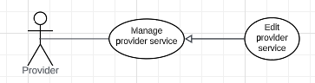

Figure: <Provider> Edit Provider Service

| **USE CASE – UC_25** | | | |
| --- | --- | --- | --- |
| **Use Case No.** | **UC_25** | **Use Case Version** | 2.0 |
| **Use Case Name** | Edit Provider Service | | |
| **Author** | Nguyen Hoang Nam | | |
| **Date** | 17/06/2023 | **Priority** | High |
| **Actor:**   * Provider (primary), system (secondary)   **Summary:**   * This use case allows a provider to edit an existing provider in his service main page.   **Goal:**   * Provider successfully updates an existing provider service and the modified provider service could be accessed in his service main page from both provider and customer view.   **Triggers:**   * Provider clicks on the “Edit Service” button on a specific provider service on the service main page.   **Preconditions:**   * User must login to the system as provider * Provider account is active in the system * The provider service must be active and existent.   **Post conditions:**   * Success:   Provider successfully updates a provider service.   * Fail: Show error message of failure to update the provider service   **Main Success Scenario:**   | **Step** | **Actor Action** | **System Response** | | --- | --- | --- | | 1 | User logins as provider | Activate provider’s availability status and displays main view board for provider | | 2 | Clicks on the "Provider Service" tab option | Display full list of provider services of the provider, categorized by service type. | | 3 | Provider clicks “Edit” button on a provider service | A provider service form is displayed with fill-in fields, which have been injected with the values of current provider service:   * Service name (required and must be an option in a dropdown list) * Unit price * Description * Checkbox for visible.   Other read-only fields include:   * Lower and upper bound for unit price * Unit * Booking commission fee. | | 4 | Provider fills in the fields that need updating and hit “Update” button at the bottom | * The system automatically updates the existing provider service in the database. * A success message is prompted to the provider screen, which then brings him back to the service main page. |   **Exceptions:**   | **No** | **Cause** | **System Response** | | --- | --- | --- | | 1 | Provider inputs an out-of-range unit price | System shows a message with a warning that the unit price is out-of-bound. Attempting to create a new provider service results in failure of such action. | | 2 | Provider inputs a description longer than max length of text box | System shows a message with a warning that the description is surpassing the length limit. Attempting to create a new provider service results in failure of such action. | | 3 | Provider leaves the service type blank | System shows a message with a warning that the service is unselected. Attempting to create a new provider service results in failure of such action. |   **Relationships:** N/A  **Business Rules:**   * Providers can update the service type of an existing provider service to one of the defined services by the system admin. * The unit and booking commission fee are fixed for all provider services of a service type. The unit price must be within the range constrained by admin. * Description max length: 1500 characters. * The provider can switch the checkbox visible on and off. This flags the visibility of such provider service on the customer view. In some cases, a specific provider service is not available sometimes, this field can be helpful. * The default value for availability is true, which means that newly created provider service is visible to all customers and guests searching for services. | | | |

##### 

##### **3.2.3.13. <Provider> Deactivate Service (Soft Delete)**

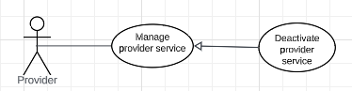

Figure: <Provider> Deactivate Service (Soft Delete)

| **USE CASE – UC_26** | | | |
| --- | --- | --- | --- |
| **Use Case No.** | **UC_26** | **Use Case Version** | 2.0 |
| **Use Case Name** | Deactivate Provider Service | | |
| **Author** | Nguyen Hoang Nam | | |
| **Date** | 17/06/2023 | **Priority** | High |
| **Actor:**   * Provider (primary), system (secondary)   **Summary:**   * This use case allows a provider to deactivate (soft delete) a provider service of his..   **Goal:**   * Provider successfully deactivates a provider service, which removes such the item from all actors’ views, but the item still remains inactive in the system.   **Triggers:**   * Provider clicks the “Delete” button on a specific provider service on the service main page.   **Preconditions:**   * User must login to the system as provider * Provider account is active in the system * The provider service to be deleted must be existent.   **Post conditions:**   * Success:   Provider successfully deletes a provider service.   * Fail: Show error message of failure to delete the new provider service   **Main Success Scenario:**   | **Step** | **Actor Action** | **System Response** | | --- | --- | --- | | 1 | User logins as provider | Activate provider’s availability status and displays main view board for provider | | 2 | Clicks on the "Provider Service" tab option | Display full list of provider services of the provider, categorized by service type. | | 3 | Provider selected a provider service to delete and clicks the “Delete” button on a provider service | The system will prompt a popup dialog asking if the provider is sure to delete this provider service with 2 options: “Yes” and “No”. There is no way to reverse this action. | | 4 | Provider clicks the “Yes” button on the popup dialog. | * The system switches the active flag of the provider service to false, hiding it from all system queries. * A finish message is displayed on the provider’s screen and he will be brought back to the service main page. |   **Exceptions:**   | **No** | **Cause** | **System Response** | | --- | --- | --- | | 1 |  |  |   **Relationships:** N/A  **Business Rules:**   * Providers can delete a provider service from his view and that of the customers. However, the deleted item still remains inactive in the system. This avoids the deletion of foreign keys in subsequent tables. * The action of deletion can only be reversed by a request for re-activation to the database admin, but this circumstance is unlikely. * The deleted provider services would not be seen by the provider, the customers and the admin. * Any child objects of the deleted provider service will remain in the system, including the bookings and the images. | | | |

##### 

##### **3.2.3.14. <Provider> View Transactions**

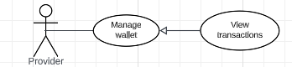

Figure: <Provider> View Transactions

| **USE CASE – UC_27** | | | |
| --- | --- | --- | --- |
| **Use Case No.** | **UC_27** | **Use Case Version** | 2.0 |
| **Use Case Name** | View Transactions | | |
| **Author** | Nguyen Hoang Nam | | |
| **Date** | 17/06/2023 | **Priority** | High |
| **Actor:**   * Provider (primary), system (secondary)   **Summary:**   * This use case allows a provider to view the transactions conducted on his wallet over the past 3 months.   **Goal:**   * Provider successfully views the transactions categorized into types over the past 3 months.   **Triggers:**   * The provider clicks on the “View Transaction History” button on the wallet main page.   **Preconditions:**   * User must login to the system as provider * Provider account is active in the system   **Post conditions:**   * Success:   Provider successfully views a list of transactions that he has executed over the past 3 months sorted temporally.   * Fail: Show error message of failure to retrieve transaction history.   **Main Success Scenario:**   | **Step** | **Actor Action** | **System Response** | | --- | --- | --- | | 1 | Provider navigates to the nav bar and clicks on the “Wallet” tab | -The system displays the wallet main page, containing specific pages for “Deposit” and “View Transaction History” and the current balance that the provider possesses. | | 2 | Provider clicks on the “View Transaction History” button. | The system displays a list of transactions that the provider has conducted, the order of which is chronologically managed. Each transaction contains the following fields:   * category (deposit/booking fee/subscription fee) * Amount of charge * Date. | | 3 | The provider can additionally perform some filtration or sorting (by date/by category) according to his desire. | The system sorts/filters/ the results based on the requirements of the provider. |   **Exceptions:**   | **No** | **Cause** | **System Response** | | --- | --- | --- | | 1 | Internal error in sorting or filtering results. | The system will prompt a message notifying the trouble and ask the provider to try again later. The provider can email system admin about this contingency. |   **Relationships:** N/A  **Business Rules:**   * Providers can view the transaction history that his wallet has been associated with over the past 3 months. * The history is not subject to modification neither by the provider nor the admin. The background worker of the system would periodically remove the past history older than 3 months old. * The transactions serve the purpose of managing the cash flow over a time period, and aids in generating the statistical figures for income summary. | | | |

##### 

##### **3.2.3.15. <Provider> Deposit money into wallet**

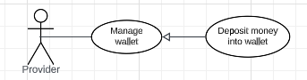

Figure: <Provider> Deposit money into wallet

| **USE CASE – UC_28** | | | |
| --- | --- | --- | --- |
| **Use Case No.** | **UC_28** | **Use Case Version** | 2.0 |
| **Use Case Name** | Deposit Money into Wallet | | |
| **Author** | Nguyen Hoang Nam | | |
| **Date** | 17/06/2023 | **Priority** | High |
| **Actor:**   * Provider (primary), system (secondary)   **Summary:**   * This use case allows a provider to deposit money into his wallet   **Goal:**   * Provider successfully deposits money into his wallet account.   **Triggers:**   * Provider clicks the “Deposit” button on the wallet management page.   **Preconditions:**   * User must login to the system as provider * Provider account is active in the system   **Post conditions:**   * Success:   Provider successfully deposits money into his current balance in the wallet.   * Fail: Show error message of failure to make a deposit.   **Main Success Scenario:**   | **Step** | **Actor Action** | **System Response** | | --- | --- | --- | | 1 | User logins as provider | Activate provider’s availability status and displays main view board for provider | | 2 | Clicks on the "Wallet" tab on the nav bar | Display button options within the wallet management page, including: deposition, view transaction history and current balance. | | 3 | Provider clicks on the “Deposition” button. | The system displays a wizard form including:   * Amount to deposit * Default method, which can be chosen at the discretions of the provider. | | 4 | Provider fills in the required fields and hits “Deposit”. | * The system saves the deposition information, and calls an API to the third-party transaction apps (like Momo or VNPay) to make the transaction. The system updates the new balance of the account. * The system also creates a new transaction entry in the Transaction table, which is retrieved later in the transaction history. |   **Exceptions:**   | **No** | **Cause** | **System Response** | | --- | --- | --- | | 1 | Internal error calling third-party API | The system displays a message or error and requires the provider to reattempt later. | | 2 | The provider enters an amount greater than balance in his bank account | The system replies with a message warning that the amount deposited surpasses the balance in his bank account and the system fails to make such a transaction. |   **Relationships:** N/A  **Business Rules:**   * Providers can deposit an amount of money into his wallet for booking commission fees and subscription fee payment. * The system relies on third-party transaction apps like Momo or VNPay for real money transactions on the provider’s account. * The amount of money deposited to the wallet is equal to the exact money subtracted in the provider’s bank account. * The history of deposition is saved in the transaction history for later retrieval. | | | |

##### 

##### **3.2.3.16. <Provider> Get Notified When Balance is Low**

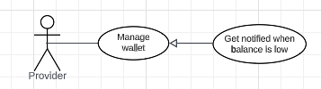

Figure: <Provider> Get Notified When Balance is Low

| **USE CASE – UC_29** | | | |
| --- | --- | --- | --- |
| **Use Case No.** | **UC_29** | **Use Case Version** | 2.0 |
| **Use Case Name** | Get Notified When Balance is Low | | |
| **Author** | Nguyen Hoang Nam | | |
| **Date** | 17/06/2023 | **Priority** | High |
| **Actor:**   * Provider (primary), system (secondary)   **Summary:**   * This use case allows a provider to get notified when his balance in the wallet is low and might not be sufficient for future charges.   **Goal:**   * Provider successfully gets notified when his wallet balance drops to the defined threshold.   **Triggers:**   * The current balance drops to or lower than the defined threshold.   **Preconditions:**   * User must login to the system as provider * Provider account is active in the system * The current balance is lower or equal to the threshold. * Provider’s email is viable.   **Post conditions:**   * Success:   Provider successfully gets notified for his low balance in the wallet.   * Fail: Show error message of failure to notify the provider when his balance is low.   **Main Success Scenario:**   | **Step** | **Actor Action** | **System Response** | | --- | --- | --- | | 1 | Conducts some fee-involved activities | Update the balance of the provider’s account. If the balance is lower than the defined threshold, the system will send an email and a popup notification as he logs in the system. | | 2 | The provider gets a notification of low balance from the system in his mailbox or logs in to receive the notification. He will subsequently need to deposit some money into his wallet. |  |   **Exceptions:**   | **No** | **Cause** | **System Response** | | --- | --- | --- | | 1 | The provider does not get notified of his low balance. | The system will fix the warning on the header of the provider’s homepage. |   **Relationships:** N/A  **Business Rules:**   * Providers get notified if the balance is lower than the first threshold (10000 by default) and second threshold (5000) through registered email and popup notification on the app. * The message will remain until the balance is brought higher than the first threshold. * In case the balance is lower than -10000, his account will be deactivated and must resolve the problem by mail to the system admin. | | | |

##### 

##### **3.2.3.17. <Provider> View Subscription Plan**

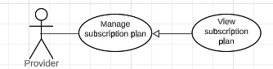

Figure: <Provider> View Subscription Plan

| **USE CASE – UC_30** | | | |
| --- | --- | --- | --- |
| **Use Case No.** | **UC_30** | **Use Case Version** | 2.0 |
| **Use Case Name** | View Subscription Plan | | |
| **Author** | Nguyen Hoang Nam | | |
| **Date** | 17/06/2023 | **Priority** | High |
| **Actor:**   * Provider (primary), system (secondary)   **Summary:**   * This use case allows a provider to view his subscription plans that he has registered up to now.   **Goal:**   * Provider successfully views the subscription plans that he has registered.   **Triggers:**   * The provider clicks on the “Registered Plans” button on the subscription plan main page.   **Preconditions:**   * User must login to the system as provider * Provider account is active in the system   **Post conditions:**   * Success:   Provider successfully views a list of subscription plans he has contracted with the latest plan being placed on top.   * Fail: Show error message of failure to retrieve subscription history.   **Main Success Scenario:**   | **Step** | **Actor Action** | **System Response** | | --- | --- | --- | | 1 | Provider navigates to the nav bar and clicks on the “Subscription” tab | The system displays the subscription plan main page, containing specific pages for “Register” and “View Subscription History” and the subscription plan that the provider is currently on. | | 2 | Provider clicks on the “View Subscription History” button. | The system displays a list of subscription plan registration that the provider has contracted, the order of which is chronologically managed. Each registration contains the following fields:   * Subscription plan registered * Amount of charge * Date * Extend option if it is the latest registration (for subscription extension) | | 3 | The provider can additionally perform some filtration or sorting (by date/by subscription plan) according to his desire. | The system sorts/filters/ the results based on the requirements of the provider. |   **Exceptions:**   | **No** | **Cause** | **System Response** | | --- | --- | --- | | 1 | Internal error in sorting or filtering results. | The system will prompt a message notifying the trouble and ask the provider to try again later. The provider can email system admin about this contingency. |   **Relationships:** N/A  **Business Rules:**   * Providers can view the subscription history that he has registered over the past 1 year. * The history is not subject to modification neither by the provider nor the admin. The background worker of the system would periodically remove the past history older than 1 year old. * The latest registration exhibits an extra feature: extend registration to allow the provider to automatically extend the plan when it reaches the end of the period. | | | |

##### 

##### **3.2.3.18. <Provider> Register a Subscription Plan**

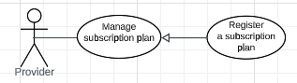

Figure: <Provider> Register a Subscription Plan

| **USE CASE – UC_31** | | | |
| --- | --- | --- | --- |
| **Use Case No.** | **UC_31** | **Use Case Version** | 2.0 |
| **Use Case Name** | Register A Subscription Plan | | |
| **Author** | Nguyen Hoang Nam | | |
| **Date** | 17/06/2023 | **Priority** | High |
| **Actor:**   * Provider (primary), system (secondary)   **Summary:**   * This use case allows a provider to register a subscription plan available in the system.   **Goal:**   * Provider successfully registers a subscription plan.   **Triggers:**   * Provider clicks the “Register” button on the selected subscription plan on the subscription page.   **Preconditions:**   * User must login to the system as provider * Provider account is active in the system * The current balance in the provider’s wallet must exceed the subscription charge of the plan he intends to register.   **Post conditions:**   * Success:   Provider successfully registers a subscription plan and his day count increments by the duration of the selected plan.   * Fail: Show error message of failure to register a plan.   **Main Success Scenario:**   | **Step** | **Actor Action** | **System Response** | | --- | --- | --- | | 1 | User logins as provider | Activate provider’s availability status and displays main view board for provider | | 2 | Clicks on the "Subscription" tab on the nav bar | Display the current subscription plan that the provider has registered, including day count left (due date). On the side bar, there are 2 options: “Register” and “View subscription history” | | 3 | Provider clicks on the “Register” button. | The system displays the current balance in the provider’s wallet and a list of available subscription plans, each of which includes details:   * Plan name * Plan description * Duration * Price * “Register” button. | | 4 | Provider selects a plan and clicks on the “Register” button of the selected plan. | * The system checks if the current balance is sufficient to make a registration. If it is, the system proceeds to save the subscription fee information in the database, and automatically creates a transaction entry in the provider’s transaction history, subtracting an amount equal to the plan price from the current balance of the provider. * The day count is extended with the duration of the plan. The provider will be sent back to the subscription main page. | | 5 | The provider can optionally set the latest subscription plan as auto-extend so that the system will automatically register a new same-kind subscription plan when the day count reaches the threshold. | * Save the auto-extend subscription and trigger the extension of the subscription plan automatically as the day count reaches the threshold. |   **Exceptions:**   | **No** | **Cause** | **System Response** | | --- | --- | --- | | 1 | Internal error adding subscription fee and transaction entry. | The system displays a message or error and requires the provider to reattempt later. | | 2 | The provider’s current balance is lower than the price of the selected subscription plan. | The system replies with a message warning that the current balance is lower than the charge, hence, it fails to make a successful registration. The system will ask the provider to deposit money into his wallet or pick another subscription plan that fits in his current balance. |   **Relationships:** N/A  **Business Rules:**   * Providers can register a subscription plan, which keeps him present on the system. * There are 4 subscription plans for providers to choose. The longer the duration, the higher the price. * The provider will be notified when his day count is lower than 5 days. If the provider’s day count is lower than -3, he will be suspended automatically by the system. | | | |

##### 

##### **3.2.3.19. <Provider> Get Notified When Subscription is Close to End**

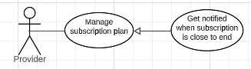

Figure: <Provider> Get Notified When Subscription is Close to End

| **USE CASE – UC_32** | | | |
| --- | --- | --- | --- |
| **Use Case No.** | **UC_32** | **Use Case Version** | 2.0 |
| **Use Case Name** | Get Notified When Subscription is Close to End | | |
| **Author** | Nguyen Hoang Nam | | |
| **Date** | 17/06/2023 | **Priority** | High |
| **Actor:**   * Provider (primary), system (secondary)   **Summary:**   * This use case allows a provider to get notified when day count (plan subscription) is near the expiration.   **Goal:**   * Provider successfully gets notified when his day count is below the defined thresholds.   **Triggers:**   * The day count drops to or lower than the defined thresholds.   **Preconditions:**   * User must login to the system as provider * Provider account is active in the system * The day count is lower or equal to the threshold. * Provider’s email is viable.   **Post conditions:**   * Success:   Provider successfully gets notified for his near expiration of subscription.   * Fail: Show error message of failure to notify the provider when the subscription is about to end.   **Main Success Scenario:**   | **Step** | **Actor Action** | **System Response** | | --- | --- | --- | | 1 |  | -The system scheduler conducts daily decrements on the day count of all providers and triggers notification to counts that are below the thresholds. | | 2 | The provider gets a notification of low balance from the system in his mailbox or logs in to receive the notification. He will subsequently need to register a subscription plan or let the system automatically extend the subscription. |  |   **Exceptions:**   | **No** | **Cause** | **System Response** | | --- | --- | --- | | 1 | The provider does not get notified of his day count. | The system will fix the warning on the header of the provider’s homepage. |   **Relationships:** N/A  **Business Rules:**   * Providers get notified if the day count is equal or lower than the first threshold (3 days), and the second threshold (1 day) through registered email and popup notification on the app. * The message will remain until the day count is brought higher than the first threshold. * In case the day count is lower than -1, his account will be deactivated and must resolve the problem by mail to the system admin. | | | |

##### 

##### **3.2.3.20.** **<Provider> Logout**

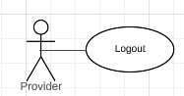

Figure: <Provider> Logout

| **USE CASE - UC33** | | | |
| --- | --- | --- | --- |
| **Use Case No.** | **UC33** | **Use Case Version** | 1.1 |
| **Use Case Name** | Logout | | |
| **Author** | Nguyen Ba Huy | | |
| **Date** | 23/06/2023 | **Priority** | Normal |
| **Actor:**  - Provider  **Summary:**  - This use case allows the provider to logout to the system.  **Goal:**  - Provider can logout from the system  **Trigger:**  - Provider sends a logout command.  **Precondition:**  - Provider must log in before logging out.  **Post Conditions:**  - Success: Provider logout to the system successfully  **Main Success Scenario:**     | **Step** | **Actor Action** | **System Response** | | --- | --- | --- | | 1 | Provider clicks “Logout” on the navigation menu. | Return the user to the home screen. |       **Relationship:** N/A.  **Business rule:**   * After logged out, user access the system as role “Provider” * Return the user to the home screen after logged out. | | | |

##### **3.2.3.21. <Provider> Update account information**

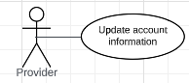

Figure: <Provider> Update account information

| **USE CASE-34 SPECIFICATION** | | | | |
| --- | --- | --- | --- | --- |
| **Use-case No.** | UC34 | **Use-case Version** | | 1.0 |
| **Use-case Name** | Update account information | | | |
| **Author** | Nguyen Ba Huy | | | |
| **Date** | 23/06/2023 | **Priority** | Normal | |
| **Actor:**  - Provider  **Summary:**  - This use case allows Provider to update their account information  **Goal:**  - Provider can update their account information.  **Triggers:**  - Provider sends an update account information command to the system.  **Preconditions:**  - Provider must login into the system with the role Provider.  **Post conditions:**  - Success: update the account information successfully  **Main Success Scenario:**   | Step | Actor | System Response | | --- | --- | --- | | 1 | Provider clicks “Account” on navigation menu | System redirect to the account screen with account information of the provider. | | 2 | Provider clicks on “Update” button | System show a form pop-up for the provider to fill in. | | 3 | Provider fills in details (name, email, phone) and hits the “Submit” button. | System will show the message “Update account information successfully” and return to the account screen. |   **Alternative Scenario:**   | Step | Actor | System Response | | --- | --- | --- | | 1 | Provider is not logged in or their account is invalid | Provider is redirected to the login/ registration page. |   **Exceptions**:     | No | Actor | System Response | | --- | --- | --- | | 1 | The provider's login session expires during the process | They will be prompted to log in again before accessing their booking history |   **Relationships:** N/A  **Business Rules:**  - Displays provider’s information based on provider’s id  - Provider’s account information must have:   1. Name of provider 2. Email 3. Phone | | | | |

#### 

#### **3.2.4.** **<Admin> Overview Use Case**

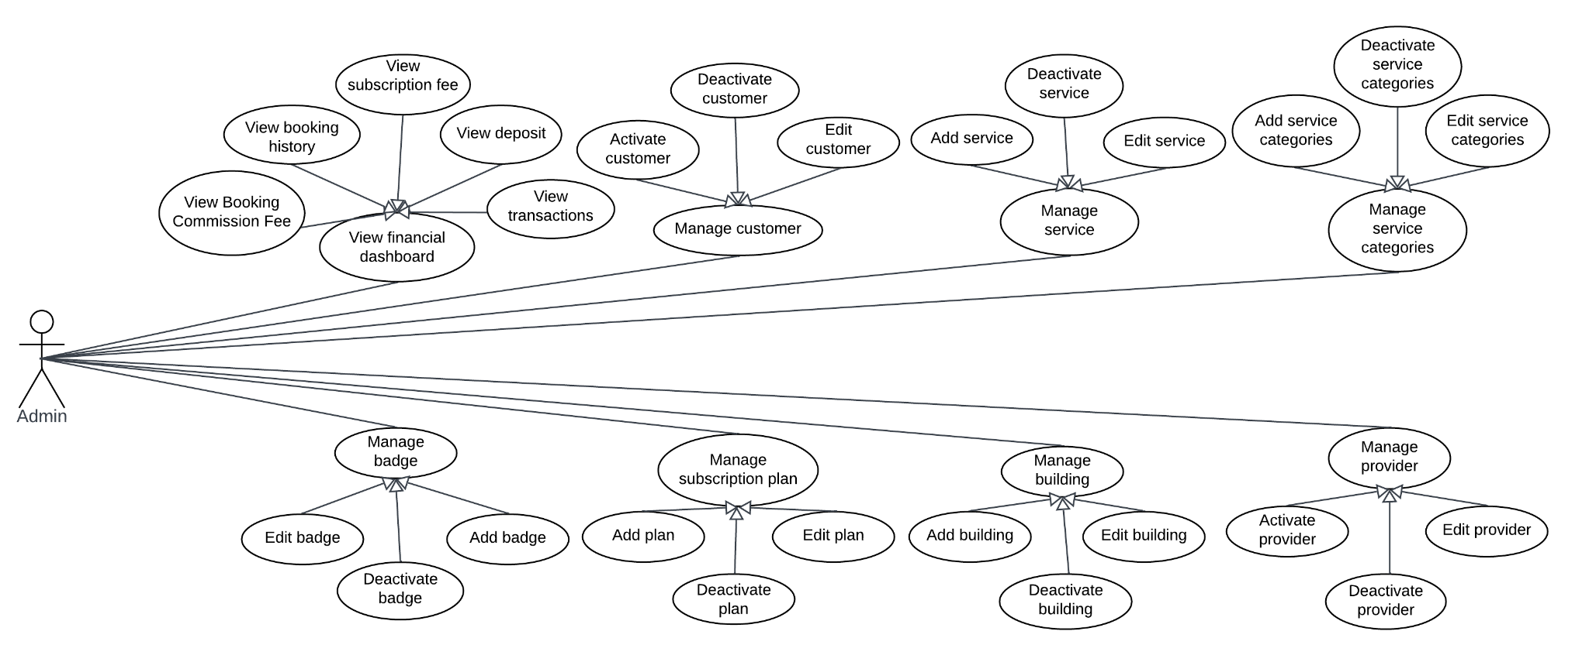

Figure: <Admin> Overview Use Case

##### **3.2.4.1. <Admin> Add service categories**

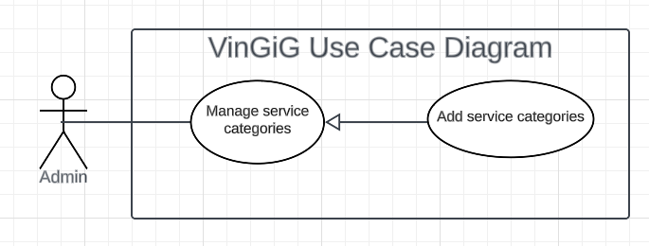

Figure: <Admin> Add service categories

| **USE CASE – UC35** | | | |
| --- | --- | --- | --- |
| **Use Case No.** | **UC35** | **Use Case Version** | 2.0 |
| **Use Case Name** | Add service categories | | |
| **Author** | Le Trung Duc | | |
| **Date** | 07/06/2023 | **Priority** | High |
| **Actor:**   * Admin   **Summary:**   * This use case allows the admin to create a new services category   **Goal:**   * The admin successfully create a new service category   **Triggers:**   * The admin clicks on “Add service categories”   **Preconditions:**   * User must login to the system * Admin account must be activated   **Post conditions:**  Admin successfully creates a new services category  **Main Success Scenario:**   | **Step** | **Actor Action** | **System Response** | | --- | --- | --- | | 1 | Clicks on the "service categories" tab on nav bar | Displays a list of existing service categories | | 2 | Selects the option to add a new service category | Show a form to enter the new service category’s details:   * Name * Description | | 3 | Enter the details of the new Service category | System shows a message that the service category is created.  [Exception 1] [Exception 2] |   **Exceptions:**   | **No** | **Cause** | **System Response** | | --- | --- | --- | | 1 | User input invalid fields | System shows message with corresponding fields:  Service type name: Must have 6 to 20 characters |  | **No** | **Cause** | **System Response** | | --- | --- | --- | | 2 | Service categories already exist | displays an error message indicating that the Service categories already exists |   **Relationships:** N/A  **Business Rules:**   * Service type name: Must have 6 to 20 characters * Admin can view the details of service before clicking “Finish”. * When Admin click “Finish”:   + Shows message “Added service category”.   + Redirects to the “Service categories list” screen. | | | |

##### 

##### **3.2.4.2. <Admin> Deactivate service categories**

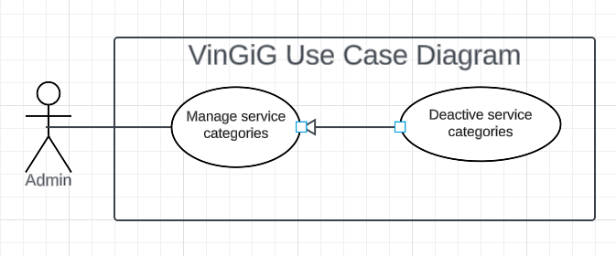

Figure: Deactivate service categories

| **USE CASE – UC36** | | | |
| --- | --- | --- | --- |
| **Use Case No.** | **UC36** | **Use Case Version** | 2.0 |
| **Use Case Name** | Deactivate service categories | | |
| **Author** | Le Trung Duc | | |
| **Date** | 07/06/2023 | **Priority** | Normal |
| **Actor:**   * Admin   **Summary:**   * This use case allows admin to deactivate service categories   **Goal:**   * Admin successfully deactivates service categories   **Triggers:**   * Admin clicks “ deactivated”   **Preconditions:**   * User must login to the system * Admin account must be activated   **Post conditions:**   * Success:   Admin successfully deactivates service categories  **Main Success Scenario:**   | **Step** | **Actor Action** | **System Response** | | --- | --- | --- | | 1 | Clicks on the "Loại dịch vụ" tab on nav bar | Displays a list of existing Service categories | | 2 | Selects the Service categories to be deactivated from the list | System shows a message that the service categories are deactivated and services are also deactivated.  [Exception 1] |   **Exceptions:**   | **No** | **Cause** | **System Response** | | --- | --- | --- | | 1 | There are services depending on this category | The system displays a message stating, "There are services dependent on this category." |   **Relationships:** Manage services  **Business Rules:**   * Admin can view the details of service before clicking “deactivate”. * When Admin click “deactivate”:   + Show message “Service categories deactivated”.   + Redirect to the “Service categories list” screen. | | | |

##### 

##### **3.2.4.3. <Admin> Edit service categories**

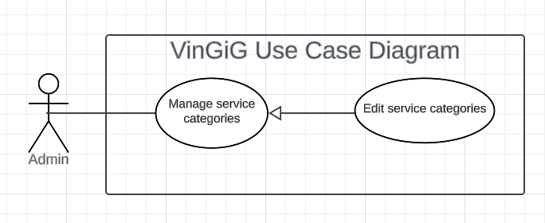

Figure: Edit service categories

| **USE CASE – UC37** | | | |
| --- | --- | --- | --- |
| **Use Case No.** | **UC37** | **Use Case Version** | 2.0 |
| **Use Case Name** | Edit service categories | | |
| **Author** | Le Trung Duc | | |
| **Date** | 07/06/2023 | **Priority** | Normal |
| **Actor:**   * Admin   **Summary:**   * This use case allows admin to edit a service category’s details   **Goal:**   * The admin successfully edits a service category’s details   **Triggers:**   * The admin clicks on “ Edit”   **Preconditions:**   * User must login to the system * Admin account must be activated   **Post conditions:**   * Success:   Admin successfully edits the selected services category’s details  **Main Success Scenario:**   | **Step** | **Actor Action** | **System Response** | | --- | --- | --- | | 1 | Clicks on the "Service Categories" tab on the nav bar | Displays a list of existing service categories | | 2 | Selects the option to edit a service category | Shows a form to enter the selected service category’s details:   * name * description | | 3 | Enters the details of the new service category | System shows a message that the service category is edited.  [Exception 1] [Exception 2]  [Exception 3] |   **Exceptions:**   | **No** | **Cause** | **System Response** | | --- | --- | --- | | 1 | User enters invalid inputs | System shows message with corresponding fields:  Service type name: Must have 6 to 20 characters |  | **No** | **Cause** | **System Response** | | --- | --- | --- | | 2 | The service category already exists | displays an error message indicating that the Service categories already exists |  | **No** | **Cause** | **System Response** | | --- | --- | --- | | 3 | There are services depending on this category | The system displays a message stating, "There are services dependent on this category." |   **Relationships:** N/A  **Business Rules:**   * Service type name: Must have 6 to 20 characters * Admin can view the details of service before clicking “finish”. * When Admin click “Finish”:   + Shows message “Service categories edited”.   + Redirects to the “Service categories list” screen. | | | |

##### **3.2.4.4. <Admin> Add services**

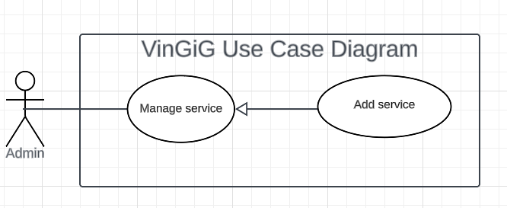

Figure: Add services

| **USE CASE – UC38** | | | |
| --- | --- | --- | --- |
| **Use Case No.** | **UC38** | **Use Case Version** | 2.0 |
| **Use Case Name** | Add services | | |
| **Author** | Le Trung Duc | | |
| **Date** | 07/06/2023 | **Priority** | High |
| **Actor:**   * Admin   **Summary:**   * This use case allows the admin to add a new service   **Goal:**   * The admin successfully adds a new service   **Triggers:**   * The admin clicks on “Add” button   **Preconditions:**   * User must login to the system as system admin * Admin account must be activated   **Post conditions:**   * Success:   Admin successfully creates a new service  **Main Success Scenario:**   | **Step** | **Actor Action** | **System Response** | | --- | --- | --- | | 1 | Clicks on the "Services" tab on the nav bar | Displays a list of existing services | | 2 | Selects the option to add a new service | Shows a form to enter new service details: name,service categories, description, unit, min price, max price, fee. | | 3 | Enters the details of the new service | Shows a message that the service is created.  [Exception 1] [Exception 2] |   **Exceptions:**   | **No** | **Cause** | **System Response** | | --- | --- | --- | | 1 | User enters invalid inputs | System shows message with corresponding fields:  Service Name: Must be at least 6 characters.  The service category name must exist in the system  Max price must be greater than min price  Min price is greater than 0  Fees greater than 0 |  | **No** | **Cause** | **System Response** | | --- | --- | --- | | 2 | The service already exists | displays an error message indicating that the service already exists. |   **Relationships:** N/A  **Business Rules:**   * Admin can view the details of service before clicking “Finish”. * When Admin click “Finish”:   + Shows message “Added service”.   + Redirects to the “Service list” screen. | | | |

##### 

##### **3.2.4.5. <Admin> Deactivate services**

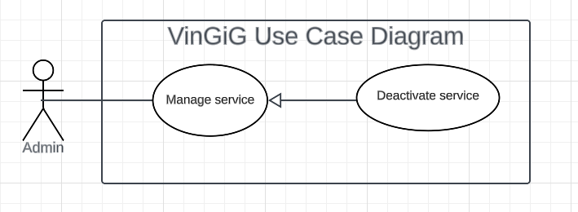

Figure: Deactivate services

| **USE CASE – UC39** | | | |
| --- | --- | --- | --- |
| **Use Case No.** | **UC39** | **Use Case Version** | 2.0 |
| **Use Case Name** | Deactivate services | | |
| **Author** | Le Trung Duc | | |
| **Date** | 07/06/2023 | **Priority** | Normal |
| **Actor:**   * Admin   **Summary:**   * This use case allows admin to deactivate a service   **Goal:**   * The admin successfully deactivates the selected service   **Triggers:**   * The admin clicks on “Delete” button   **Preconditions:**   * User must login to the system * Admin account must be activated   **Post conditions:**  Admin successfully deactivates a service  **Main Success Scenario:**   | **Step** | **Actor Action** | **System Response** | | --- | --- | --- | | 1 | Clicks on the "services" tab on nav bar | Displays a list of existing services | | 2 | Selects the service to be deactivated from the list | System shows a message that the service is deactivated. |   **Exceptions: N/A**  **Relationships:** N/A  **Business Rules:**   * Admin can view the details of service before clicking “deactivate”. * When Admin click “Finish”:   + Shows message “Service deactivated”.   + Redirects to the “Service list” screen. | | | |

##### 

##### 

##### 

##### 

##### 

##### 

##### **3.2.4.6. <Admin> Edit services**

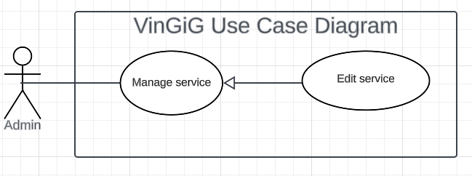

Figure: Edit services

| **USE CASE – UC40** | | | |
| --- | --- | --- | --- |
| **Use Case No.** | **UC40** | **Use Case Version** | 2.0 |
| **Use Case Name** | Edit services | | |
| **Author** | Le Trung Duc | | |
| **Date** | 07/06/2023 | **Priority** | Normal |
| **Actor:**   * Admin   **Summary:**   * This use case allows admin to edit a service’s details   **Goal:**   * The admin successfully edit the selected service’s details   **Triggers:**   * The admin clicks on “ Edit”   **Preconditions:**   * User must login to the system * Admin account must be activated   **Post conditions:**  Admin successfully edits the selected service’s details  **Main Success Scenario:**   | **Step** | **Actor Action** | **System Response** | | --- | --- | --- | | 1 | Clicks on the "services" tab on nav bar | Displays a list of existing services | | 2 | Selects the option to edit a service category | Shows a form to enter the service’s details:   * Name * service categories * description | | 3 | Enters the details of the new service | System shows a message that the service is edited.  [Exception 1] [Exception 2] |   **Exceptions:**   | **No** | **Cause** | **System Response** | | --- | --- | --- | | 1 | User inputs invalid fields | System shows message with corresponding fields:  Service Name: Must be 6 to 20 characters.  Service type name must exist in the system  Max price must be greater than min pride  Min pride is greater than 0  Fees greater than 0 |  | **No** | **Cause** | **System Response** | | --- | --- | --- | | 2 | Service already exists | displays an error message indicating that the service already exists |   **Relationships:** N/A  **Business Rules:**  Service Name: Must be 6 to 20 characters.  Service type name must exist in the system  Max price must be greater than min pride  Min pride is greater than 0  Fees greater than 0   * The admin can view the details of the service before clicking “Finish”. * When the admin clicks on “Finish”:   + Show message “Service edited”.   + Redirect to the “Service list” screen. | | | |

##### 

##### **3.2.4.7. <Admin> Add buildings**

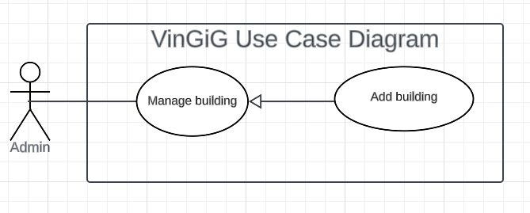

Figure: Add building

| **USE CASE – UC41** | | | |
| --- | --- | --- | --- |
| **Use Case No.** | **UC41** | **Use Case Version** | 2.0 |
| **Use Case Name** | Add buildings | | |
| **Author** | Le Trung Duc | | |
| **Date** | 07/06/2023 | **Priority** | High |
| **Actor:**   * Admin   **Summary:**   * This use case allows admin to add a new building   **Goal:**   * Admin successfully adds a new building   **Triggers:**   * Admin clicks on “Add buildings”   **Preconditions:**   * User must login to the system * Admin account must be activated   **Post conditions:**  Admin successfully adds a new building  **Main Success Scenario:**   | **Step** | **Actor Action** | **System Response** | | --- | --- | --- | | 1 | Clicks on the "Building" tab on nav bar | Displays a list of existing buildings | | 2 | Selects the option to add a new building | Show a form to enter the new building’s details (name, description.) | | 3 | Enter the details of the new building | System shows a message that the building is created.  [Exception 1] [Exception 2] |   **Exceptions:**   | **No** | **Cause** | **System Response** | | --- | --- | --- | | 1 | User input invalid fields | System shows message with corresponding fields:  Building name: Must have 6 to 20 characters. |  | **No** | **Cause** | **System Response** | | --- | --- | --- | | 2 | The building already exists | displays an error message indicating that the building already exists |   **Relationships:** Manage provider, Manage customer  **Business Rules:**   * Building name: Must have 6 to 20 characters. * Admin can view the details of the building before clicking “finish”. * When Admin click “finish”:   + Show message “Building Added”.   + Redirect to the “Building list” screen. | | | |

##### 

##### **3.2.4.8. <Admin> Deactivate buildings**

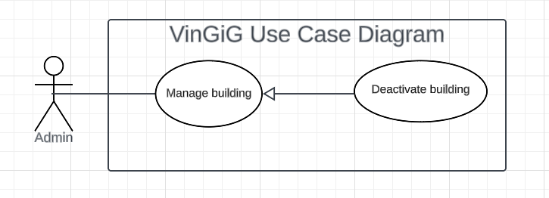

Figure: Deactivate buildings

| **USE CASE – UC42** | | | |
| --- | --- | --- | --- |
| **Use Case No.** | **UC42** | **Use Case Version** | 2.0 |
| **Use Case Name** | Deactivate buildings | | |
| **Author** | Le Trung Duc | | |
| **Date** | 07/06/2023 | **Priority** | Normal |
| **Actor:**   * Admin   **Summary:**   * This use case allows admin to deactivate a building   **Goal:**   * Admin successfully deactivate the selected building   **Triggers:**   * Admin click “ Deactivate”   **Preconditions:**   * User must login to the system * Admin account must be activated   **Post conditions:**  Admin successfully deactivate the selected building  **Main Success Scenario:**   | **Step** | **Actor Action** | **System Response** | | --- | --- | --- | | 1 | Clicks on the "building" tab on nav bar | Displays a list of existing buildings | | 2 | Selects the building to be deactivated from the list | System shows a message that the building is deactivated. |   **Exceptions:**   | **No** | **Cause** | **System Response** | | --- | --- | --- | | 1 | There are providers and customers dependent on this building | Shows a message indicating, "There are providers and customers dependent on this building." |   **Relationships:** Manage provider, Manage customer  **Business Rules:**   * Admin can view the details of service before clicking “finish”. * When Admin click “finish”:   + Show message “Building deactivated”.   + Redirect to the “Building list” screen. | | | |

##### 

##### **3.2.4.9. <Admin> Edit buildings**

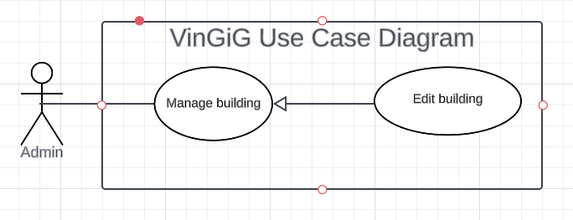

Figure: Edit buildings

| **USE CASE – UC43** | | | |
| --- | --- | --- | --- |
| **Use Case No.** | **UC43** | **Use Case Version** | 2.0 |
| **Use Case Name** | Edit buildings | | |
| **Author** | Le Trung Duc | | |
| **Date** | 07/06/2023 | **Priority** | Normal |
| **Actor:**   * Admin   **Summary:**   * This use case allows admin to edit a building’s details   **Goal:**   * Admin successfully edit the selected building’s details   **Triggers:**   * Admin clicks on “Manage building”   **Preconditions:**   * User must login to the system * Admin account must be activated   **Post conditions:**  Admin successfully edits the selected building’s details  **Main Success Scenario:**   | **Step** | **Actor Action** | **System Response** | | --- | --- | --- | | 1 | Clicks on the "Building" tab on nav bar | Displays a list of existing buildings | | 2 | Selects the option to edit a building’s details | Shows a form to enter the building details | | 3 | Enters the details of the new building (name, description, etc.) | System shows a message that the building’s details are edited.  [Exception 1] [Exception 2] |   **Exceptions:**   | **No** | **Cause** | **System Response** | | --- | --- | --- | | 1 | User inputs invalid fields | System shows message with corresponding fields:  Building name: Must have 6 to 20 characters. |  | **No** | **Cause** | **System Response** | | --- | --- | --- | | 2 | The building already exists | Displays an error message indicating that the building already exists |  | **No** | **Cause** | **System Response** | | --- | --- | --- | | 3 | There are providers and customers dependent on this building | Shows a message indicating, "There are providers and customers dependent on this building." |   **Relationships:** N/A  **Business Rules:**  Building name: Must have 6 to 20 characters.   * Admin can view the details of the building before clicking “Finish”. * When Admin clicks “Finish”:   + Show message “Building edited”.   + Redirect to the “Building list” screen. | | | |

##### 

##### **3.2.4.10. <Admin> Activate providers**

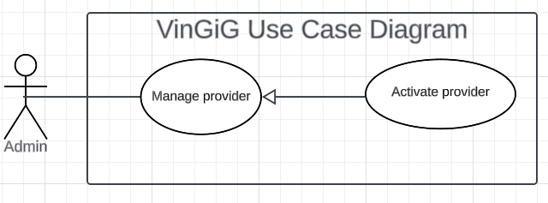

Figure: Activate providers

| **USE CASE – UC44** | | | |
| --- | --- | --- | --- |
| **Use Case No.** | **UC44** | **Use Case Version** | 2.0 |
| **Use Case Name** | Activate providers | | |
| **Author** | Le Trung Duc | | |
| **Date** | 07/06/2023 | **Priority** | High |
| **Actor:**   * Admin   **Summary:**   * This use case allows the admin to activate a provider   **Goal:**   * Admin successfully activates a provider   **Triggers:**   * Admin clicks on “ Activate”   **Preconditions:**   * User must login to the system * Admin account must be activated   **Post conditions:**  Admin successfully activates the provider  **Main Success Scenario:**   | **Step** | **Actor Action** | **System Response** | | --- | --- | --- | | 1 | Clicks on the "Providers" tab on nav bar | Displays a list of existing providers | | 2 | Selects the option to activate a provider | System shows a message that the provider is activated. |   **Exceptions:** N/A  **Relationships:** N/A  **Business Rules:**   * Admin can view the details of the provider before clicking “Finish”. * When Admin Clicks “Finish”:   + Show message “Provider is activated”.   + Redirect to the “Provider list” screen. | | | |

##### 

##### **3.2.4.11. <Admin> Deactivate providers**

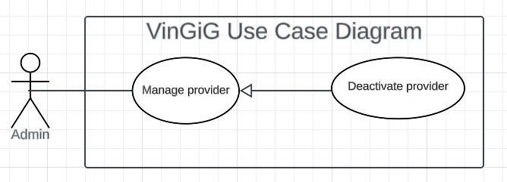

Figure: Deactivate providers

| **USE CASE – UC45** | | | |
| --- | --- | --- | --- |
| **Use Case No.** | **UC45** | **Use Case Version** | 2.0 |
| **Use Case Name** | Deactivate providers | | |
| **Author** | Le Trung Duc | | |
| **Date** | 07/06/2023 | **Priority** | Normal |
| **Actor:**   * Admin   **Summary:**   * This use case allows admin to deactivate a provider   **Goal:**   * Admin successfully deactivates the selected provider   **Triggers:**   * Admin click “Deactivate”   **Preconditions:**   * User must login to the system * Admin account must be activated   **Post conditions:**   * Success:   Admin successfully deactivate the provider  **Main Success Scenario:**   | **Step** | **Actor Action** | **System Response** | | --- | --- | --- | | 1 | Clicks on the "nhà cung cấp" tab on nav bar | Displays a list of existing provider | | 2 | Selects the option to deactivate a provider | System shows a message that the provider is deactivated. |   **Exceptions:** N/A  **Relationships:** N/A  **Business Rules:**   * Admin can view the details of the provider before clicking “Finish”. * When Admin clicks “Finish”:   + Show message “Provider deactivated”.   + Redirect to the “Provider list” screen. | | | |

##### 

##### **3.2.4.12. <Admin> Edit providers**

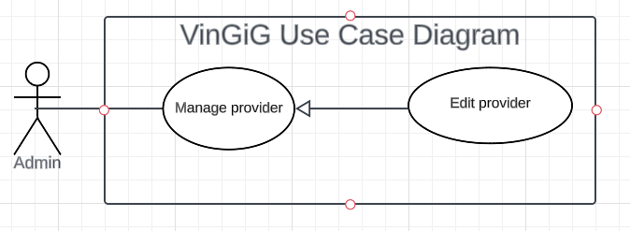

Figure: Edit providers

| **USE CASE – UC46** | | | |
| --- | --- | --- | --- |
| **Use Case No.** | **UC46** | **Use Case Version** | 2.0 |
| **Use Case Name** | Edit a providers | | |
| **Author** | Le Trung Duc | | |
| **Date** | 07/06/2023 | **Priority** | Normal |
| **Actor:**   * Admin   **Summary:**   * This use case allows admin to edit a provider’s details   **Goal:**   * Admin successfully edits provider   **Triggers:**   * Admin clicks on “Edit”   **Preconditions:**   * User must login to the system * Admin account must be activated   **Post conditions:**  Admin successfully edits provider  **Main Success Scenario:**   | **Step** | **Actor Action** | **System Response** | | --- | --- | --- | | 1 | Clicks on the "Providers" tab on nav bar | Displays a list of existing provider | | 2 | Selects the option to edit a Provider | Shows a form to enter the provider’s details (username, password, gender, building, badge, avatar, rating, fullname, email, phone, address.) | | 3 | Enters the details of the provider | System shows a message that the provider is edited.  [Exception 1] [Exception 2] |   **Exceptions:**   | **No** | **Cause** | **System Response** | | --- | --- | --- | | 1 | User enters invalid inputs | System shows message with corresponding fields:  Username: Must be 6 to 20 characters.  Password: Must have 6 to 20 characters.  Building : must exist in the table building in the database  Badge: must exist in  Table badge in database  Avatar: it's a picture  Rating: must be less than 5  Full name: Must be 6 to 20 characters.  Email: must have email a format  Phone: must have 10 digits  Address: Must be 6 to 20 characters. |  | **No** | **Cause** | **System Response** | | --- | --- | --- | | 2 | Provider already exists | Displays an error message indicating that the provider already exists |   **Relationships:** N/A  **Business Rules:**  Username: Must be 6 to 20 characters.  Password: Must have 6 to 20 characters.  Building : must exist in the table building in the database  Badge: must exist in  Table badge in database  Avatar: it's a picture  Rating: must be less than 5  Full name: Must be 6 to 20 characters.  Email: must have email a format  Phone: must have 10 digits  Address: Must be 6 to 20 characters.   * Admin can view the details of the provider before clicking “Finish”. * When Admin clicks “Finish”:   + Shows message “Provider edited”.   + Redirects to the “Provider list” screen. | | | |

##### 

##### **3.2.4.13. <Admin> Activate customers**

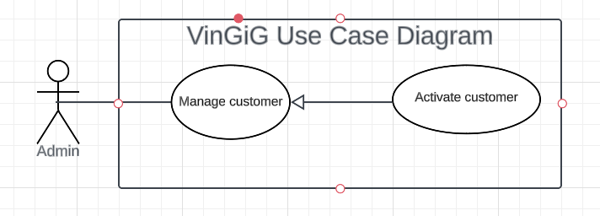

Figure: Activate customers

| **USE CASE – UC47** | | | |
| --- | --- | --- | --- |
| **Use Case No.** | **UC47** | **Use Case Version** | 2.0 |
| **Use Case Name** | Activate customers | | |
| **Author** | Le Trung Duc | | |
| **Date** | 07/06/2023 | **Priority** | High |
| **Actor:**   * Admin   **Summary:**   * This use case allows admin to activate customers   **Goal:**   * Admin successfully activates customer   **Triggers:**   * Admin click “Add”   **Preconditions:**   * User must login to the system * Admin account must be activated   **Post conditions:**   * Success:   Admin successfully activates customer  **Main Success Scenario:**   | **Step** | **Actor Action** | **System Response** | | --- | --- | --- | | 1 | Clicks on the "Customer" tab on the nav bar | Displays a list of existing customers | | 2 | selects the option to activate a customer | System shows a message that the customer is activated |   **Exceptions:** N/A  **Relationships:** N/A  **Business Rules:**   * Admin can view the details of the customer before clicking “Finish”. * When Admin click “finish”:   + Shows message “Customer activated”.   + Redirects to the “Customer list” screen. | | | |

##### 

##### **3.2.4.14. <Admin> Deactivate customers**

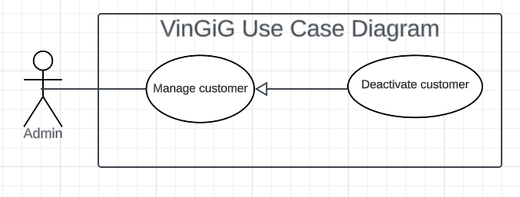

Figure: Deactivate customers

| **USE CASE – UC48** | | | |
| --- | --- | --- | --- |
| **Use Case No.** | **UC48** | **Use Case Version** | 2.0 |
| **Use Case Name** | Deactivate customers | | |
| **Author** | Le Trung Duc | | |
| **Date** | 07/06/2023 | **Priority** | Normal |
| **Actor:**   * Admin   **Summary:**   * This use case allows admin to deactivate customers   **Goal:**   * Admin successfully deactivates customer   **Triggers:**   * Admin click “Deactivate”   **Preconditions:**   * User must login to the system * Admin account must be activated   **Post conditions:**   * Success:   Admin successfully detective customer  **Main Success Scenario:**   | **Step** | **Actor Action** | **System Response** | | --- | --- | --- | | 1 | Clicks on the "Customer" on the nav bar | Displays a list of existing customer | | 2 | Selects the option to deactivate a customer | System shows a message that the customer is deactivated. |   **Exceptions:** N/A  **Relationships:** N/A  **Business Rules:**   * Admin can view the details of the customer before clicking “Finish”. * When Admin click “Finish”:   + Show message “Customer is deactivated”.   + Redirect to the “Customer list” screen. | | | |

##### **3.2.4.15. <Admin> Edit customers**

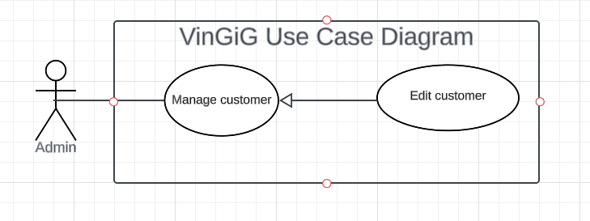

Figure: Edit customers

| **USE CASE – UC49** | | | |
| --- | --- | --- | --- |
| **Use Case No.** | **UC49** | **Use Case Version** | 2.0 |
| **Use Case Name** | Edit customers | | |
| **Author** | Le Trung Duc | | |
| **Date** | 07/06/2023 | **Priority** | Normal |
| **Actor:**   * Admin   **Summary:**   * This use case allows admin to edit customer   **Goal:**   * Admin successfully edits customer   **Triggers:**   * Admin clicks “Edit”   **Preconditions:**   * User must login to the system * Admin account must be activated   **Post conditions:**   * Success:   Admin successfully edit customer  **Main Success Scenario:**   | **Step** | **Actor Action** | **System Response** | | --- | --- | --- | | 1 | Clicks on the "Customer" tab on nav bar | Displays a list of existing customer | | 2 | Selects the option to edit the customer. | Shows a form to enter new customer details(username, password, gender, building, avatar, rating, fullname, email, phone, address) | | 3 | Enters the details of the new customer | System shows a message that the customer is edited.  [Exception 1] [Exception 2] |   **Exceptions:**   | **No** | **Cause** | **System Response** | | --- | --- | --- | | 1 | User inputs invalid fields | System shows message with corresponding fields:  Username: Must be 6 to 20 characters.  Password: Must have 6 to 20 characters.  Building : must exist in the table building in the database  Avatar: it's a picture  Rating: must be less than 5  Full name: Must be 6 to 20 characters.  Email: must have email a format  Phone: must have 10 digits  Address: Must be 6 to 20 characters. |  | **No** | **Cause** | **System Response** | | --- | --- | --- | | 2 | Provider already exists | Displays an error message indicating that the customer already exists |   **Relationships:** N/A  **Business Rules:**  Username: Must be 6 to 20 characters.  Password: Must have 6 to 20 characters.  Building : must exist in the table building in the database  Avatar: it's a picture  Rating: must be less than 5  Full name: Must be 6 to 20 characters.  Email: must have email a format  Phone: must have 10 digits  Address: Must be 6 to 20 characters.   * Admin can view the details of the customer before clicking “finish”. * When Admin click “finish”:   + Show message “Customer edited”.   + Redirect to the “Customer list” screen. | | | |

##### 

##### **3.2.4.16. <Admin> Add a badge**

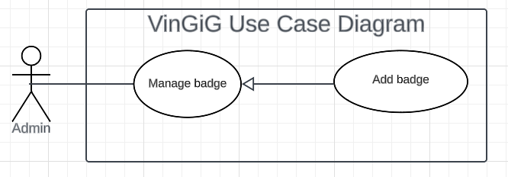

Figure: Add a badge

| USE CASE-50 SPECIFICATION | | | | |
| --- | --- | --- | --- | --- |
| Use-case No. | UC050 | Use-case Version | | 1.0 |
| Use-case Name | Add a badge | | | |
| Author | Le Nguyen Tien Nhat | | | |
| Date | 14/06/2023 | Priority | Normal | |
| **Actor:**  Admin  **Summary**:  The system allows the admin to add a badge.  **Goal**:  The admin is able to add a new badge.  **Triggers**:  The admin clicks on the “Add a badge” option.  **Preconditions**:  The user has to log in successfully as an admin.  **Post Conditions**:  The badge is added to the system.  **Main Success Scenario**:   | No. | Actor’s action | System’s response | | --- | --- | --- | | 1 | The logged-in user selects the “Manage badges” option on the admin homepage. | The system navigates the user to “Badges management” screen | | 2 | The user clicks on “Add a badge” option | The system shows a form. The form includes input fields for: The badge’s name, description and its corresponding benefits. | | 3 | The user enters the badge’s details and clicks “Submit” button | The system added the newly created badge. [Exception] |     **Alternative Scenario**:  N/A  **Exceptions**:     | No. | Cause | System’s response | | --- | --- | --- | | 1 | The user enters wrong a format input | The system displays a pop-up message: the entered data is invalid. |   **Relationships**:  This use case relates to the "Manage badges” functionality in the user system.  **Business Rules**:  The system validates the user’s input with the following constraints:  o   Badge’s name: has less than 20 characters.  o   Description: has less than 200 characters.  o   Benefit: has less than 200 characters. | | | | |

##### **3.2.4.17. <Admin> Edit a badge**

Figure: Edit a badge

| USE CASE-51 SPECIFICATION | | | | |
| --- | --- | --- | --- | --- |
| Use-case No. | UC51 | Use-case Version | | 1.0 |
| Use-case Name | Edit a badge | | | |
| Author | Le Nguyen Tien Nhat | | | |
| Date | 14/06/2023 | Priority | Normal | |
| **Actor:**  Admin  **Summary**:  The system allows the admin to edit badge details, including: the badge’s name, its description and corresponding benefits.  **Goal**:  The admin is able to edit a selected badge’s details.  **Triggers**:  The admin clicks on the “Edit” option on a chosen badge.  **Preconditions**:  The user has to log in successfully as an admin.  **Post Conditions**:  The chosen badge’s details are edited successfully.  **Main Success Scenario**:   | No. | Actor’s action | System’s response | | --- | --- | --- | | 1 | The logged user selects the “Manage badges” option on the admin homepage. | The system navigates the user to “Badges management” screen | | 2 | The user clicks on “Edit a badge” option | The system displays a list of active badges. | | 3 | The user selects the “Edit” button on a badge. | The system shows a form. The form includes input fields for: Badge name, description and benefit. The fields are already filled with the badge’s previous details. Input validation is required. | | 4 | The user enters the badge’s details and clicks “Submit” button | The system updates the badge’s details. [Exception] |     **Alternative Scenario**:  N/A  **Exceptions**:     | No. | Cause | System’s response | | --- | --- | --- | | 1 | The user enters wrong a format input | The system displays a pop-up message: the entered data is invalid. |   **Relationships**:  This use case relates to the "Manage badges” functionality in the user system.  **Business Rules**:  The system validates the user’s input with the following constraints:  o   Badge name: has less than 20 characters.  o   Description: has less than 200 characters.  o   Benefit: has less than 200 characters. | | | | |

##### **3.2.4.18. <Admin> Deactivate a badge**

Figure: Deactivate badge

| USE CASE-52 SPECIFICATION | | | | |
| --- | --- | --- | --- | --- |
| Use-case No. | UC52 | Use-case Version | | 1.0 |
| Use-case Name | Deactivate a badge | | | |
| Author | Le Nguyen Tien Nhat | | | |
| Date | 14/06/2023 | Priority | Normal | |
| **Actor:**  Admin  **Summary**:  The system allows the admin to deactivate a badge.  **Goal**:  The admin is able to deactivate a selected badge.  **Triggers**:  The admin clicks on the “Deactivate a badge” option.  **Preconditions**:  The user has to log in successfully as an admin.  **Post Conditions**:  The badge is deactivated successfully.  **Main Success Scenario**:   | No. | Actor’s action | System’s response | | --- | --- | --- | | 1 | The logged admin selects the “Badges” tab on the admin’s homepage nav bar. | The system navigates the user to “Badges management” screen | | 2 | The user clicks on “Deactivate a badge” option | The system shows a list of active badges, including badgeID, badgeName and a link to details. [Exception 1] | | 3 | The user selects “Deactivate” button on a selected badge | The system displays a pop-up message: “Are you sure to deactivate this badge?” | | 4 | The user clicks on the “Confirm” button on the pop-up screen. | The system updates the badge’s active state. [Exception 2] |     **Alternative Scenario**:  N/A  **Exceptions**:  N/A  **Relationships**:  This use case relates to the "Manage badges” functionality in the user system.  **Business Rules**:  The list of active badges must provide these details: Badge’s ID and badge’s name. | | | | |

##### 

##### **3.2.4.19. <Admin> Add a plan**

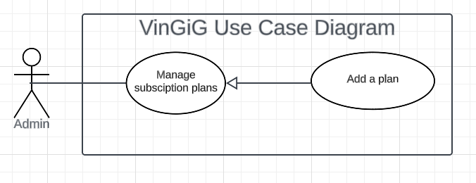

Figure: Add a plan

| USE CASE-53 SPECIFICATION | | | | |
| --- | --- | --- | --- | --- |
| Use-case No. | UC53 | Use-case Version | | 1.0 |
| Use-case Name | Add a plan | | | |
| Author | Le Nguyen Tien Nhat | | | |
| Date | 14/06/2023 | Priority | Normal | |
| **Actor:**  Admin  **Summary**:  The system allows the admin to add a subscription plan.  **Goal**:  The admin is able to add a new subscription plan.  **Triggers**:  The admin clicks on the “Add a plan” option.  **Preconditions**:  The user has to log in successfully as an admin.  **Post Conditions**:  Success scenario: The subscription plan is added to the system.  **Main Success Scenario**:   | No. | Actor’s action | System’s response | | --- | --- | --- | | 1 | The logged user selects the “Manage subscription plans” option on the admin homepage. | The system navigates the user to “Subscription plans management” screen | | 2 | The user clicks on “Add a plan” option | The system shows a form with input fields: name, description, duration and price. These fields require validation. | | 3 | The user enters the details and clicks “Submit” button | The system added the newly created subscription plan to the database. [Exception] |     **Alternative Scenario**:  N/A  **Exceptions**:     | No. | Cause | System’s response | | --- | --- | --- | | 1 | The user enters wrong a format input | The system displays a pop-up message: the entered data is invalid. |   **Relationships**:  This use case relates to the "Manage subscription plans” functionality in the user system.  **Business Rules**:  The system validates the user’s input with the following constraints:  o   Name: has less than 20 characters.  o   Description: has less than 200 characters.  o   Duration: Date a format, dd/mm/yyyy.  o   Price: has less than 7 digits, with VND as currency. | | | | |
| **3.2.4.20. <Admin> Edit a plan**   Figure: Edit a plan   | USE CASE-54 SPECIFICATION | | | | | | --- | --- | --- | --- | --- | | Use-case No. | UC54 | Use-case Version | | 1.0 | | Use-case Name | Edit a plan | | | | | Author | Le Nguyen Tien Nhat | | | | | Date | 14/06/2023 | Priority | Normal | | | **Actor:**  Admin  **Summary**:  The system allows the admin to edit a subscription plan’s details.  **Goal**:  The admin is able to edit the subscription plan’s details.  **Triggers**:  The admin clicks on the “Edit a plan” option.  **Preconditions**:  The user has to log in successfully as an admin.  **Post Conditions**:  The subscription plan’s details are edited successfully.  **Main Success Scenario**:   | No. | Actor’s action | System’s response | | --- | --- | --- | | 1 | The logged user selects the “Manage subscription plans” option on the admin homepage. | The system navigates the user to “Subscription plans management” screen | | 2 | The user clicks on “Edit a plan” option | The system displays a list of active plans. [Exception 1] | | 3 | The user selects the “Edit” button on a selected plan. | The system displays a pop-up form, including: the plan’s description, its duration and price. Input validation required. | | 4 | The user enters the details and clicks “Submit” button | The system updates the subscription plan’s details. [Exception 2] |     **Alternative Scenario**:  N/A  **Exceptions**:     | No. | Cause | System’s response | | --- | --- | --- | | 1 | The system fails to load the data | The system displays an error message: “Currently unable to retrieve data”. The user can click on the button “Back to homepage” to navigate back to the homepage. | | 2 | The user enters wrong a format input | The system displays a pop-up message: the entered data is invalid. |   **Relationships**:  This use case relates to the "Manage badges” functionality in the user system.  **Business Rules**:  **-** The system validates the user’s input with the following constraints:  o   Name: has less than 20 characters.  o   Description: has less than 200 characters.  o   Duration: Date a format, dd/mm/yyyy.  o   Price: has less than 7 digits, with VND as currency.   * Each subscription plan is displayed with basic details: the plan’s ID, name, duration and price. | | | | |  **3.2.4.21. <Admin> Deactivate a plan** | | | | |

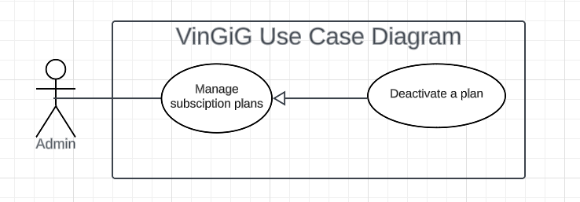

Figure: Deactivate a plan

| USE CASE-55 SPECIFICATION | | | | |
| --- | --- | --- | --- | --- |
| Use-case No. | UC55 | Use-case Version | | 1.0 |
| Use-case Name | Deactivate a plan | | | |
| Author | Le Nguyen Tien Nhat | | | |
| Date | 14/06/2023 | Priority | Normal | |
| **Actor:**  Admin  **Summary**:  The system allows the admin to deactivate a subscription plan instead of hard-deletion.  **Goal**:  The user is able to deactivate a selected subscription plan.  **Triggers**:  The admin clicks on the “Deactivate a plan” option.  **Preconditions**:  The user has to log in successfully as an admin.  **Post Conditions**:  The subscription plan is deactivated successfully.  **Main Success Scenario**:   | No. | Actor’s action | System’s response | | --- | --- | --- | | 1 | The logged user selects the “Manage subscription plans” option on the admin homepage. | The system navigates the user to the “Subscription plans management” screen | | 2 | The user clicks on “Deactivate a plan” option | The system shows a list of subscription plans.  [Exception 1] | | 3 | The user selects “Deactivate” button on a selected subscription plan | The system displays a pop-up message: “Are you sure to deactivate this subscription plan?” | | 4 | The user clicks on the “Confirm” button on the pop-up screen. | The system updates the subscription plan’s active state.  [Exception 2] |     **Alternative Scenario**:  N/A  **Exceptions**:     | No. | Exception | System’s response | | --- | --- | --- | | 1 | The system fails to retrieve data | The system displays an error message | | 2 | The system fails to update the selected subscription plan’s state. | The system displays an error message: “Failed to update, please try again”. After that, the user is navigated back to the “Subscription plans management” screen. |   **Relationships**:  This use case relates to the "Manage subscription plans” functionality in the user system.  **Business Rules**:  All displayed subscription plans on the “Subscription plans management” screen must be in active state as default.  When the system displays a pop-up message: “Are you sure to deactivate this subscription plan?”, the admin is provided an option to cancel or deactivate the selected subscription plan. | | | | |

##### **3.2.4.22. <Admin> View transactions**

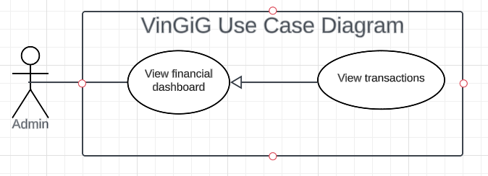

Figure: View transactions

| USE CASE-56 SPECIFICATION | | | | |
| --- | --- | --- | --- | --- |
| Use-case No. | UC56 | Use-case Version | | 1.0 |
| Use-case Name | View transactions | | | |
| Author | Le Nguyen Tien Nhat | | | |
| Date | 14/06/2023 | Priority | Normal | |
| **Actor**:  Admin  **Summary**:  The system allows the user to view transaction history. The user also can view some basic details of each transaction: transactionID, amount and date.  **Goal**:  The user is able to view the transactions.  **Triggers**:  The admin clicks on the “View transactions” option.  **Preconditions**:  The user has to log in successfully as an admin.  **Post Conditions**:  A list of transactions has to be displayed by the system.  **Main Success Scenario**:   | No. | Actor’s action | System’s response | | --- | --- | --- | | 1 | The logged user selects the “Financial dashboard” option on the admin homepage. | The system navigates the user to “Financial dashboard” screen | | 2 | The user clicks on “View transactions” option | The system shows a list of transactions.  [Exception] |   **Alternative Scenario**:  N/A  **Exceptions**:     | No. | Exception | System’s response | | --- | --- | --- | | 1 | The user hasn’t made any purchase. | The system displays a message: “There is no transaction”. The user can click on the button “Back to homepage” to navigate back to the homepage. |   **Relationships**:  This use case relates to the "View financial dashboard” functionality in the user system.  **Business Rules**:  Each transaction is displayed with basic details: transactionID, amount and date (datetime a format: dd/mm/yyyy hh:mm:ss). | | | | |

##### **3.2.4.23. <Admin> View subscription fee**

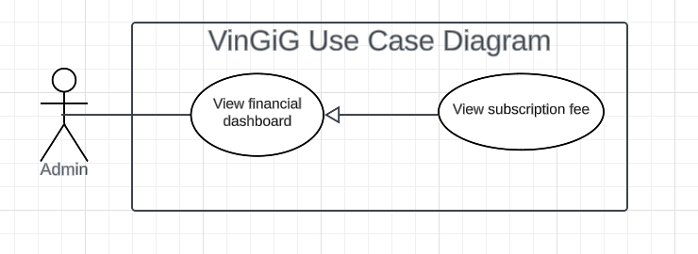

Figure: View subscription fee

| USE CASE-57 SPECIFICATION | | | | |
| --- | --- | --- | --- | --- |
| Use-case No. | UC57 | Use-case Version | | 1.0 |
| Use-case Name | View subscription fee | | | |
| Author | Le Nguyen Tien Nhat | | | |
| Date | 14/06/2023 | Priority | Normal | |
| **Actor:**  Admin  **Summary**:  The system allows the user to view subscription status of the providers.  **Goal**:  The user adds a new service successfully.  **Triggers**:  The admin clicks on the “View subscription fee” option.  **Preconditions**:  The user has to log in successfully as an admin.  **Post Conditions**:  A table of subscriptions is displayed.  **Main Success Scenario**:   | No. | Actor’s action | System’s response | | --- | --- | --- | | 1 | The logged user selects the “Financial dashboard” option on the admin homepage. | The system navigates the user to “Financial dashboard” screen | | 2 | The user clicks on “View subscription fee” option | The system shows the “Subscription fee” screen. The screen displays a list of subscriptions. [Exception] |   **Alternative Scenario**:  N/A  **Exceptions**:     | No. | Exception | System’s response | | --- | --- | --- | | 1 | The customer doesn’t subscribe to any plan after all, or the system failed to load the data. | The system displays a message: “There is no subscription fee”. The user can click on the button “Back to homepage” to navigate back to the homepage. |   **Relationships**:  This use case relates to the "View financial dashboard” functionality in the user system.  **Business Rules**:  For each subscription shown on the screen, its detailed information is provided, including: ID of the provider, ID of the subscribed plan, and total amount of fee and subscription date (datetime a format: dd/mm/yyyy hh:mm:ss). | | | | |

##### **3.2.4.24. <Admin> View booking history**

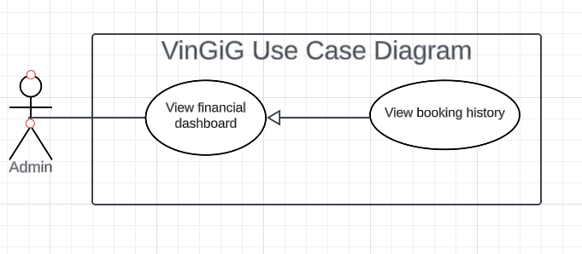

Figure: View booking history

| USE CASE-58 SPECIFICATION | | | | |
| --- | --- | --- | --- | --- |
| Use-case No. | UC58 | Use-case Version | | 1.0 |
| Use-case Name | View booking history | | | |
| Author | Le Nguyen Tien Nhat | | | |
| Date | 14/06/2023 | Priority | Normal | |
| **Actor:**  Admin  **Summary**:  The system allows the user to view booking history.  **Goal**:  The user can view booking history.  **Triggers**:  The provider clicks on the “View booking history” option.  **Preconditions**:  The user has to log in successfully as an admin.  **Post Conditions**:  A table of booking history is displayed.  **Main Success Scenario**:   | No. | Actor’s action | System’s response | | --- | --- | --- | | 1 | The logged user selects the “Financial dashboard” option on the admin homepage. | The system navigates the user to “Financial dashboard” screen | | 2 | The user clicks on “View booking history” option | The system shows the “Booking history” screen. The screen displays a list of bookings made by customers. [Exception] |   **Alternative Scenario**:  N/A  **Exceptions**:     | No. | Exception | System’s response | | --- | --- | --- | | 1 | The customer doesn’t make any booking, or the system fails to load the data. | The system displays a message: “There is no subscription fee”. The user can click on the button “Back to homepage” to navigate back to the homepage. |   **Relationships**:  This use case relates to the "View financial dashboard” functionality in the user system.  **Business Rules**:  For each booking, detailed information is provided, including the IDs of: the booking, the customer booked, the provider’s service, the customer’s rating and the booking date (datetime a format: dd/mm/yyyy hh:mm:ss). | | | | |

##### **3.2.4.25. <Admin> View booking commission fee**

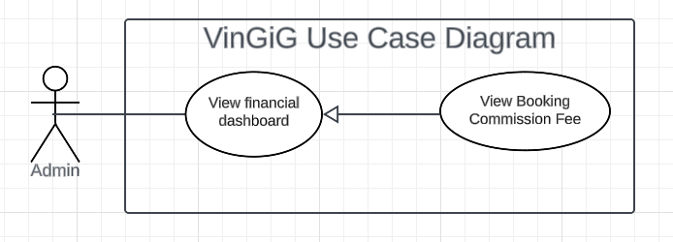

Figure: View booking commission fee

| USE CASE-59 SPECIFICATION | | | | |
| --- | --- | --- | --- | --- |
| Use-case No. | UC59 | Use-case Version | | 1.0 |
| Use-case Name | View booking commision fee | | | |
| Author | Le Nguyen Tien Nhat | | | |
| Date | 14/06/2023 | Priority | Normal | |
| **Actor:**  Admin  **Summary**:  The system allows the user to view the commission fee for corresponding booking.  **Goal**:  The admin can view the commission fee of each booking.  **Triggers**:  The admin clicks on the “View booking commission fee” option.  **Preconditions**:  The user has to log in successfully as an admin.  **Post Conditions**:  Information of each commission fee is successfully displayed.  **Main Success Scenario**:   | No. | Actor’s action | System’s response | | --- | --- | --- | | 1 | The logged user selects the “Financial dashboard” option on the admin homepage. | The system navigates the user to “Financial dashboard” screen | | 2 | The user clicks on “View booking commission fee” option | The system shows the “Booking commission fee” screen. The screen displays a list of every commission made by customers. |   **Alternative Scenario**:  N/A  **Exceptions**:     | No. | Exception | System’s response | | --- | --- | --- | | 1 | The system fails to retrieve data | The system navigates the user to an error page. The page has a message “requested data is currently unavailable” and a button to navigate back to the homepage. |   **Relationships**:  This use case relates to the "View financial dashboard” functionality in the user system.  **Business Rules**:  For each commission, detailed information is provided, including the commission’s ID, the booking ID, the amount of money and commission’s date (datetime format: dd/mm/yyyy hh:mm:ss). | | | | |

##### 

##### **3.2.4.26. <Admin> View deposit**

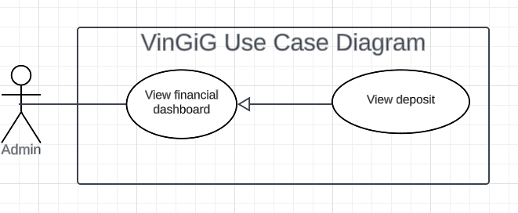

Figure: View deposit

| USE CASE-60 SPECIFICATION | | | | |
| --- | --- | --- | --- | --- |
| Use-case No. | UC60 | Use-case Version | | 1.0 |
| Use-case Name | View deposit | | | |
| Author | Le Nguyen Tien Nhat | | | |
| Date | 14/06/2023 | Priority | Normal | |
| **Actor:**  Admin  **Summary**:  The system allows the user to view the amount of money prepaid by the providers (deposit).  **Goal**:  The admin is able to view the deposits’ basic details.  **Triggers**:  The admin wants to view the deposits.  **Preconditions**:  The user has to log in successfully as an admin.  **Post Conditions**:  Information of each deposit is successfully displayed  **Main Success Scenario**:   | No. | Actor’s action | System’s response | | --- | --- | --- | | 1 | The logged user selects the “Financial dashboard” option on the admin homepage. | The system navigates the user to “Financial dashboard” screen | | 2 | The user clicks on “View deposit” option | The system shows the “View deposit” screen. The screen displays a list of every deposit paid by customers. [Exception] |   **Alternative Scenario**:  N/A  **Exceptions**:     | No. | Exception | System’s response | | --- | --- | --- | | 1 | The system fails to retrieve data | The user is navigated to an error homepage. The page has a message “Failed to retrieve the requested data” and a button to navigate to the homepage. |   **Relationships**:  This use case relates to the "View financial dashboard” functionality in the user system.  **Business Rules**:  For each deposit, detailed information is provided, including the deposit’s ID, the provider’s ID that paid the deposit, the amount of money, payment method (credit card or online banking) and purchase date (datetime a format: dd/mm/yyyy hh:mm:ss). | | | | |

# 4. Non-Functional Requirements

## 4**.1.** **Usability**

- UI fits for all common browsers and sizes.

- A customer/guest can be familiar with the flow of the application after 30 minutes of perusing.

- A provider should feel free to use the application skillfully after 2 hours of training.

- Admin should be able to use the application effectively after 2 days of experience.

## 4**.2.** **Reliability**

- The system runs smoothly without any crash, especially during rush hours.

- In the event of system failure, it takes no more than 1 hour to recover the operation of the application.

- Downtimes occur fewer than 3 times per month.

## 4**.3. Performance**

- Response time for any request should take less than 3 seconds for non-booking events.

- For booking-involved events, it should take less than 5 seconds for the latencies.

- The system can handle 1000 simultaneous users.